Christ the King
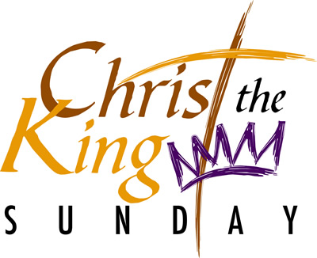
In the aftermath of the presidential election in the United States a lot of back pedaling is now taking place on both sides of the Atlantic. Many harsh words were spoken, in particular of the victor of the campaign by European leaders some of whom at least are now regretting their words.

In the American Church harsh words were also uttered but none more so than those of the archbishop of Philadelphia, Charles Chapter who made his views known very publicly. He said the choice facing the American people was between and I quote,
“A vulgar, boorish lout and dis-respecter of women, with a serious impulse control problem; or a scheming, robotic liar with a lifelong appetite for power and an entourage riddled with anti-Catholic bigots.”

I wonder what he really thought, eh.

His words and the campaign itself reminded me of the old adage,
“Power corrupts, absolute power corrupts absolutely.”

While that may well be the case in human terms, it is not true in divine terms. Here the image of one who rules is given to us in the scriptures and it is the polar opposite of the kind of sentiments expressed of those two candidates.
Christ whose Kingship we celebrate is the Son of David the one chosen to be a shepherd to Israel, what gentler image could there possible be than that.

Christ our King has defeated the darkness that lives in the human heart and frees us from the chains and darkness of sin. Far from lording it over us, far from seeking out power and privilege Christ whom we acclaim as our King pays for our sins by his death on the cross. This man who has done nothing wrong pleads and promises on our behalf; “Today you will be with me in paradise.”

All of that ought to make us think about how we exercise power over others, within our families and our works. The power and authority given to us ought to be exercised for the good of others and not in a manner that is self-seeking and rewarding. That way, we do our bit to make the presence of the Kingdom felt.

