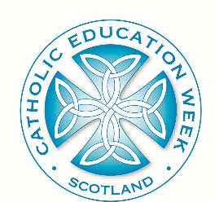
Catholic Education Week
ADDRESS OF THE HOLY FATHER TO PUPILS
Sports Arena of St Mary’s University College
Extract One:
It is not often that a Pope, or indeed anyone else, has the opportunity to speak to the students of all the Catholic schools of England, Wales and Scotland at the same time. And since I have the chance now, there is something I very much want to say to you. I hope that among those of you listening to me today there are some of the future saints of the twenty-first century. What God wants most of all for each one of you is that you should become holy. He loves you much more than you could ever begin to imagine, and he wants the very best for you. And by far the best thing for you is to grow in holiness.

Perhaps some of you have never thought about this before. Perhaps some of you think being a saint is not for you. Let me explain what I mean. When we are young, we can usually think of people that we look up to, people we admire, people we want to be like. It could be someone we meet in our daily lives that we hold in great esteem. Or it could be someone famous. We live in a celebrity culture, and young people are often encouraged to model themselves on figures from the world of sport or entertainment. My question for you is this: what are the qualities you see in others that you would most like to have yourselves? What kind of person would you really like to be?

