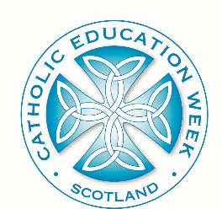
Catholic Education Week
ADDRESS OF THE HOLY FATHER TO PUPILS
Sports Arena of St Mary’s University College
Extract Three:
In your Catholic schools, there is always a bigger picture over and above the individual subjects you study, the different skills you learn. All the work you do is placed in the context of growing in friendship with God, and all that flows from that friendship. So you learn not just to be good students, but good citizens, good people. As you move higher up the school, you have to make choices regarding the subjects you study, you begin to specialize with a view to what you are going to do later on in life. That is right and proper. But always remember that every subject you study is part of a bigger picture. Never allow yourselves to become narrow. The world needs good scientists, but a scientific outlook becomes dangerously narrow if it ignores the religious or ethical dimension of life, just as religion becomes narrow if it rejects the legitimate contribution of science to our understanding of the world. We need good historians and philosophers and economists, but if the account they give of human life within their particular field is too narrowly focused, they can lead us seriously astray.
A good school provides a rounded education for the whole person. And a good Catholic school, over and above this, should help all its students to become saints. I know that there are many non-Catholics studying in the Catholic schools in Great Britain, and I wish to include all of you in my words today. I pray that you too will feel encouraged to practise virtue and to grow in knowledge and friendship with God alongside your Catholic classmates. You are a reminder to them of the bigger picture that exists outside the school, and indeed, it is only right that respect and friendship for members of other religious traditions should be among the virtues learned in a Catholic school. I hope too that you will want to share with everyone you meet the values and insights you have learned through the Christian education you have received.
Dear friends, I thank you for your attention, I promise to pray for you, and I ask you to pray for me. I hope to see many of you next August, at the World Youth Day in Madrid. In the meantime, may God bless you all!

