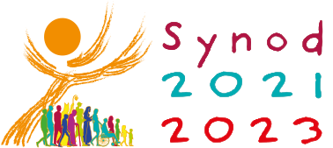
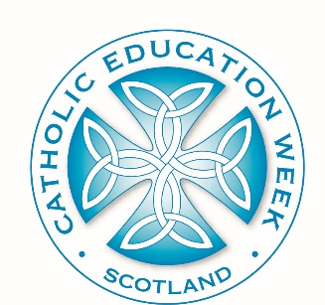
Catholic Education Week 2022

Communion, Participation, Mission

Primary Second Level Resources

Activity | Outline | Resources
Activity One: Introductory lesson: Learning about the Synod and exploring the logo. | Introduction to Catholic Education Week and theme: Communion, Participation, Mission. Using the teachers’ notes in the Second Level lesson one PowerPoint# explore the Synod and the logo in more detail. Pupils should annotate their own copy of the logo# (this could be done in pairs) while listening to reflective questions. Pupils feedback and logo is explained. The session is brought to a close with a short time of prayer (see teachers’ notes in the PowerPoint file). | PowerPoint (including teachers’ notes) #  Logo Annotating Sheet Second Level #
Activity Two: Understanding Communion, Participation, Mission | Begin with the short time of prayer and scripture reading (see teachers’ notes in the PowerPoint). Explain to the pupils that they are going to explore this year’s Catholic Education Week theme in more detail. Can they remember it? On large A3 pieces of paper write the words Communion, Participation, Mission. Give the pupils dictionaries and ask them in small groups/pairs to write down/illustrate everything they know about this word. They should discuss alternative definitions, where they have heard these words before, what the words might mean in the context of the Church/our Catholic school etc.  Allow the groups to feedback before sharing an adapted version of the definitions that have been provided for the Synod. Think back to the opening scripture passage. Can the pupils identify the themes communion, participation, mission in this passage?  Activity: Discuss the key features of the infographics with the pupils. Pupils should then create an infographic explaining theme Communion, Participation, Mission. This could be done using IT or paper and pens. | PowerPoint (including teachers’ notes) #  A3 paper and pens  A4 paper and pens/IT equipment
Activity Three: Communion, Participation, Mission in our school communities | Using the PowerPoint and teachers’ notes provided begin the lesson with the Synod prayer. Recap the previous day’s learning with Think, Pair and Share about the definitions of the words: Communion, Participation, Mission. Explain to the pupils that we have been asked (as part of the Synod) to reflect on how we are as a Church. Today we are going to reflect upon how we are as a Catholic school. Specifically how we live out Communion, Participation, Mission. With the three words on the board, take suggestions from the pupils as to how we do each of these things as a school community e.g. Communion: how often do we gather together as Children of God (prayer, Mass, rosary, assembly etc.) Is there anything we could improve? This could also be done with large pieces of paper which the children annotate. Once you have gathered a number of suggestions for each ask the pupils to choose one thing that they personally would like to improve on this year. In their jotters the pupils should write a prayer to the Holy Spirit asking that they are given the gifts, strength, confidence to do this important task. | PowerPoint (including teachers’ notes) #  RE jotters

