
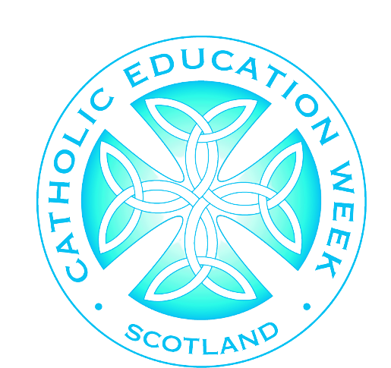
Our School are celebrating
Catholic Education Week
Prayer Supper

Our School are celebrating

Our School are celebrating
SAMPLE PROGRAMME
Use this space to add details of your event.
6.00pm | Supper
6.30pm | Welcome and introduction from Pupil Chaplaincy Team/SLT/HT/Caritas/PFFA/RE Coordinator.
6.45pm | Evening prayer lead by learners.
7.00pm | Short presentation on history and identity of Catholic Education (see CEW speaker notes).
7.15pm | Learner showcase.
7.30pm | Close and Thanks.

Our school are celebrating
and invite you to our
@scesdirector
#CEWPrayerBreakfast
#PilgrimsOfHope



