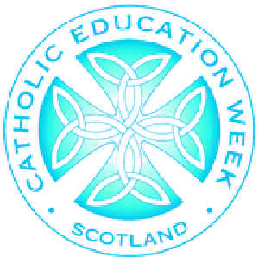

Catholic Education Week
and invite you to our

Prayer Breakfast
Our School are celebrating
*
E
D
I
T

H
E
R
E

T
O

A
D
D

S
C
H
O
O
L

C
O
N
T
A
C
T

D
E
T
A
I
L
S
@scesdirector
#CEWPrayerBreakfast
#PilgrimsOfHope
Friday 15th November
*Edit here to add times.
‘Pilgrims of Hope’
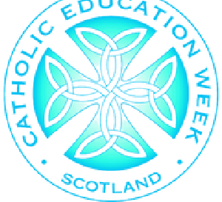
‘Pilgrims of Faith’
@scesdirector
#CEWPrayerBreakfast
#PilgrimsOfHope
0830
Breakfast
0900
Welcome and introduction from pupil chaplaincy
team/SLT/HT/Caritas/PFFA/RE Coordinator
0915
Morning Offering led by learners
0925
Short presentation on history and identity of Catholic Education
).
see CEW speaker notes
(
0945
Day 1

of Novena to St Margaret of Scotland
0955
Close and thanks.
1000
Optional for those able to stay; tea/coffee, tour and learner
showcase.
Catholic Education Week

Prayer Breakfast

