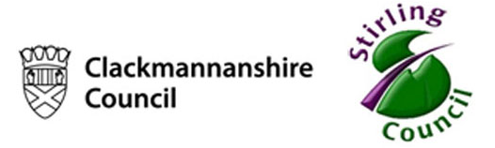


Called to Teach in a Catholic School?
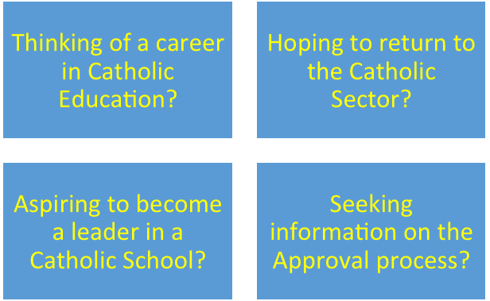

Key Speakers:
Michael McGrath - Director of SCES
Michael Canning – Former Catholic Head Teacher and Life Coach

St.Mary’s Primary School, Park Drive, Stirling, FK8 0EH
Tuesday 29th March 2016
Coffee & Registration 3.30-3.45pm

For more information and to register your attendance please email: toftj46s@glow.sch.uk or phone: 01786 812294

