Contents

Teaching in a Catholic School 4

How Do I Become a Teacher? 6

Advice and Support 8

Curriculum for Excellence 11

Getting It Right for Every Child 13

The National Improvement Framework 14

Useful Links 18

APHTA Recruitment Support

The Archdiocesan Primary Head Teachers Association (APHTA) was established by the late Cardinal Winning as a vehicle to support closer working links between the Archdiocese of Glasgow and the Head Teachers of primary schools in the Archdiocese. It is also a means of Head Teachers supporting each other in furthering the mission of the Catholic school and in delivering a rich and comprehensive RE Programme.

In light of the current shortage of Catholic primary teachers, APHTA have established a recruitment group dedicated to guiding and supporting prospective Catholic primary teachers.
Last year a group of APHTA mentors supported a number of students through the application and interview process for Glasgow University’s MA (Hons) and Post Grad Primary courses. The APHTA mentors intend to offer the same advice and support again this year in the form of two recruitment events (see key dates section). At these events you will be appointed a mentor who will provide one to one support throughout the application and interview process.

If you are interested in becoming a Catholic primary teacher and would like to benefit from the advice and support of the APHTA group please attend one of the recruitment events advertised on the back page of this booklet.

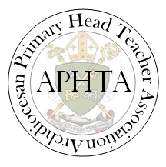
​

Teaching in a Catholic School

What is distinctive about the Catholic School?

Catholic schools offer a vision based upon the central teachings and values of the Catholic Church. They aim to help all students to develop their fullest potential, preparing them for life, informing their minds and forming their characters so that they can contribute with others to the transformation of their world – building God’s kingdom. Catholic Schools are communities which are open, welcoming and inclusive, seeking to prepare pupils to find happiness and to lead lives of goodness, built upon Christian values, personal integrity and moral courage. They promote genuine human growth, not only for Catholic pupils but for those of other faith traditions and those with stances for living which may be independent of religious belief. Catholic Schools are challenged to provide their students with structured opportunities of encounter with Jesus, opportunities to learn about His life, to understand His teaching, to develop the virtues and values which He promotes and to follow His witness in service to others.

What is School Ethos?
The dictionary defines ethos a ‘the guiding beliefs, standards or ideals that characterise or pervade a group, a community, a people… the spirit that motivates the ideas, customs and practices of a people’. This definition is helpful because it highlights first of all the pervasive nature of ethos.

In a school, ethos touches on all aspects of its operation but its very pervasiveness means that it is hard to pin down. It can be part of the ‘taken for granted’ about school life. Secondly, the definition makes it clear that ethos affects our practice. It is not an abstract idea but something which affects what we do and how we do it. So it helps us to understand why we act in particular ways and why our actions can be different in different schools.’ Munn, P (2002), p.5

What is the Catholic School ethos?

The Catholic school ethos is a loved experience and permeates every aspect of school life.

“A Catholic school’s ‘ethos’ may be understood to be the outward signs and experiences of the teachings of Christ and the Catholic Church in the totality of daily life in a Catholic school.”

What is the Charter for Catholic Schools?

The Charter for Catholic Schools in Scotland summarizes the key characteristics which all Catholic schools in Scotland strive to feature through the experiences and the service which they offer. It provides a useful set of reference points for school staff and parents to use in their school evaluation and planning.


Church Approval

The relevant legislation on the management of denominational schools in Scotland states: "A teacher appointed to any post on the staff of any such school by the education authority. . . shall be required to be approved as regards religious belief and character by representatives of the church or denominational body in whose interest the school has been conducted. "
Guidance for teachers seeking Approval
To enable Councils to fulfil their statutory responsibilities, the Catholic Church requires to be assured that the personal "religious belief and character" of a teacher is appropriate to the duties associated with the teaching post for which he/she has applied.

When seeking approval, a teacher must demonstrate how his/her personal “religious belief and character” enables him/her to undertake the duties of the particular teaching post within the context of a Catholic school, with its particular mission, values and ethos, as outlined in A Charter for Catholic Schools in Scotland.

All teachers who seek approval must provide a reference from a suitable person who can testify to the teacher’s personal “religious belief and character”. The reference for a Catholic teacher must be provided by the teacher’s parish priest who should be able to testify to the teacher’s personal “religious belief and character”.

For those teaching posts which impact on the teaching of Religious Education, teachers will be expected to provide evidence of having obtained an appropriate teaching qualification in Catholic Religious Education.
How Do I Become a Teacher?

There are various avenues open to anyone wishing to prepare for teaching in Scotland.

- The University of Aberdeen
- University of Dundee
- The University of Edinburgh
- University of Glasgow
- University of the Highlands and Islands
- The University of Stirling
- The University of Strathclyde
- University of the West of Scotland

You can qualify as a teacher by either:
- Completing a four year Bachelor of Education degree course in Primary Education and certain Secondary Subjects (normally Design and Technology, Music, Physical Education and Religious Education)

- Complete a three/four year degree in essentially any subject then complete Post Graduate Diploma in Education.

Qualification to Teach Religious Education

There are two ways in which you can gain the Catholic Teacher’s Certificate in Religious Education (CTC):
- the Certificate in Religious Education by Distance-learning (CREDL) course
- the Setting Out on the Road course.

Certificate in Religious Education by Distance Learning (CREDL)
The Certificate in Religious Education by Distance Learning (CREDL)is the University of Glasgow route for qualified teachers, or for students studying an ITE programme at other universities. It is an on-line distance learning course and covers aspects of Theological Education over two semesters. Tuition fees for 2018-19 £455 per 30 Credits. Fee information is subject to change and is for guidance only
More information at: https://www.gla.ac.uk/postgraduate/taught/religiouseducationbydistancelearning/#tab=1

Setting Out on the Road

Is a course which leads to the award of the Catholic Teacher's Certificate (CTC) enabling the recipient to teach Religious Education in the Catholic school. It is delivered by the St Andrew's Foundation for Catholic Teacher Education at the University of Glasgow. Setting Out on the Road is for qualified teachers who have not yet obtained their CTC. It offers a blended learning model of 4 study days and distance-learning across one school year. Cost £310 (2018-19 price).

More information at: https://www.gla.ac.uk/schools/education/cpd/cpdforteachers/religiouseducation/settingoutontheroad/#/fees,teachingdates

Advice and Support

The Application Process
- There will be a deadline for applications: know when it is and plan to complete and submit your form in plenty of time.

- Your Personal Statement is very important. Make sure you include details of involvement in working with children. This can be in school, parish, Guides, Brownies, or Sports Clubs etc. If you have not had experience working with children – organise some. Contact your local primary school or the one you attended as a pupil and explain that you wish to gain experience as you intend to apply for teaching. If they are unable to help then get in touch with one of the contacts in this booklet.

- You may be applying to a number of Universities, however, make explicit your intention is to teach in a Catholic school. This will be taken into account when you are sent on Teaching Experience. Ensure you explain how important your faith is. As with the bullet point above, give details of any involvement with your church: Liturgy Group, HCPT etc.

- Proof read your application form and proof read it again. Ask someone else to do this too. Make sure that there are no spelling or grammatical mistakes as this gives the wrong impression of someone wishing to pursue a career in teaching.

The Interview Process
PREPARE, PREPARE, PREPARE
- Preparation is crucial.

- Understand what teaching entails. It will put you in a good position if you are aware of the role of the teacher. Having experience helping in a primary school is invaluable. Watch what the teachers in classes are doing and take notes.

- Ask them to tell you about aspects of their job that you do not see: planning and preparing for lessons, assessment and tracking etc.

- Find out about current issues affecting education in Scotland; practicalities of the job (what happens day-to-day in classroom/school setting – if you haven’t had work experience within a school, organise this asap – local schools / previous primary school may be able to help).

- Faith – consider your own faith and the impact this will have on a school. Think about the teacher’s role in developing faith: teaching the faith, sacramental preparation, encouraging children to pray, being a role model-treating everyone with love and respect, etc.

- Make a list of reasons why you are an ideal candidate for teaching and give examples e.g. supporting others in learning situations, working in teams, curricular strengths, clubs and groups supported, leadership roles undertaken.

- Think about your skills and personality: things like being a good communicator, patience, sense of humour, well-organised, team player etc.

- Look over your application, particularly your personal statement - this is what gets you over first hurdle to the interview.

The Interview Day

- Dress appropriately for a professional interview – first impressions can’t be changed. Your best outfit may be fabulous on a night out with your friends but is it suitable for interview?

- Be punctual. Leave in plenty of time to reach the interview and allow for the possibility of delays.

- Greet interviewers confidently – make eye contact and remember to smile. The interviewers will want you to give a good account of yourself. Let your personality show, they will be thinking about how you are able to relate to people. You may be nervous but understand the interviewers will take account of this.

- Listen carefully and answer the question asked. Sometimes there is a temptation to give a prepared answer. This is fine if it answers the question asked.

- Don’t be afraid to ask for clarification or for the question to be repeated

- Consider the section above on preparation for interview and use the points you have been studying in your answer.

- Use positive language and sell yourself. Be confident to say if you are a ‘skilled’ communicator, have ‘strength’ in a particular area etc.
- During the interview you will be given a choice between a denominational and non-denominational question. If you wish to work in a Catholic school it is important that you choose the denominational question.

The Written Task
- If you are asked to complete a written task then take time to read the question. Be clear and concise.

- Make a quick plan to structure your writing.

- Think about time constraints and what is practical to produce in the given time

- Leave time at the end so you can proof read to correct any grammatical / spelling errors

Curriculum for Excellence

​​
Curriculum for Excellence is intended to help children and young people gain the knowledge, skills and attributes needed for life in the 21st century, including skills for learning, life and work.
Its purpose is often summed up as helping children and young people to become:
- Successful learners
- Confident individuals
- Responsible citizens
- Effective contributors
These are referred to as the four capacities.

What is the curriculum and what does it include?
Curriculum for Excellence is designed to achieve a transformation in education in Scotland by providing a coherent, more flexible and enriched curriculum from 3 to 18. The term curriculum is understood to mean - everything that is planned for children and young people throughout their education, not just what happens in the classroom.

Curriculum for Excellence includes four contexts for learning:
- Curriculum areas and subjects
- Interdisciplinary learning
- Ethos and life of the school
- Opportunities for personal achievement

Curriculum Levels and Stages
The curriculum has two stages: the broad general education (from the early years to the end of S3) and the senior phase (S4 to S6).
The broad general education has five levels (early, first, second, third and fourth). The senior phase is designed to build on the experiences and outcomes of the broad general education, and to allow young people to take qualifications and courses that suit their abilities and interests.

Curriculum Areas
There are eight curriculum areas:
- Expressive arts
- Health and wellbeing
- Languages (including English, Gaidhlig, Gaelic learners and modern languages)
- Mathematics
- Religious and moral education
- Sciences
- Social studies
- Technologies
Literacy, numeracy and health and wellbeing are recognised as being particularly important – these areas are seen as being the ‘responsibility of all’ staff.

Principles of Curriculum Design
There are seven broad principles that practitioners should take into consideration when planning children’s learning:
- Challenge and enjoyment
- Breadth
- Progression
- Depth
- Personalisation and choice
- Coherence
- Relevance

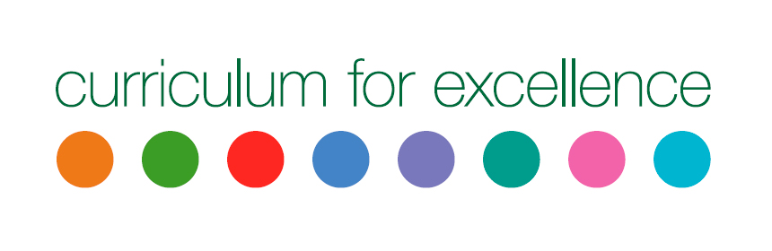

Getting It Right for Every Child (GIRFEC)

GIRFEC is the national approach in Scotland to improving outcomes and supporting the wellbeing of our children and young people by offering the right help at the right time from the right people. It supports them and their parent(s) to work in partnership with the services that can help them.

It puts the rights and wellbeing of children and young people at the heart of the services that support them – such as early years services, schools, and the NHS – to ensure that everyone works together to improve outcomes for a child or young person.

Most children get all the support and help they need from their parent(s), wider family and local community, in partnership with services like health and education. Where extra support is needed, the GIRFEC approach aims to make that support easy to access and seamless, with the child at the centre.

It is for all children and young people because it is impossible to predict if or when they might need extra support.

GIRFEC means:
- You understand what is happening and why.
- You have been listened to carefully and your wishes have been heard, understood and taken into consideration.
- You feel confident about the help you are getting.
- You are appropriately involved in discussions and decisions that affect you.
- You can rely on appropriate help being available as soon as possible.
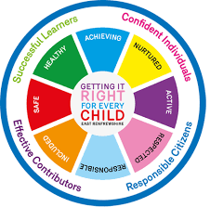
- You experience a more straightforward and co-ordinated response from the people working with you.

The National Improvement Framework

The National Improvement Framework for Scottish education is an ambitious strategy to help all children to achieve their full potential as successful learners, confident individuals, responsible citizens and effective contributors. The Framework sets out how evidence is gathered to information, making sure that we are all focussed on improving standards for our children, and in our schools.

The National Improvement Framework priorities are:
- To improve attainment for all, particularly in literacy and numeracy
- To improve the learning progress of every child, by reducing inequality in education
- To improve children and young people’s health and wellbeing
- To improve employability skills and sustained positive school leaver destinations for all young people

Drawn from international research, six areas for improvement have been identified. New evidence will be gathered in all of these. Children and young people’s learning, their opportunities when they leave school and their health and wellbeing will improve when:
- Children make progress in their learning, taking ownership of it and understanding their next steps
- Parents/carers are involved in their children’s learning and know how to help them
- High quality teaching and excellent classroom practice are delivered consistently and teachers know how to help all children make progress
- School leadership is strong
- Children, parents, teachers, headteachers, local and national government and partners al have a clear understanding of what successful learning and teaching looks like
- All participants in education at national, local, school and family level have the same priorities, use the same assessment at key points and share information openly

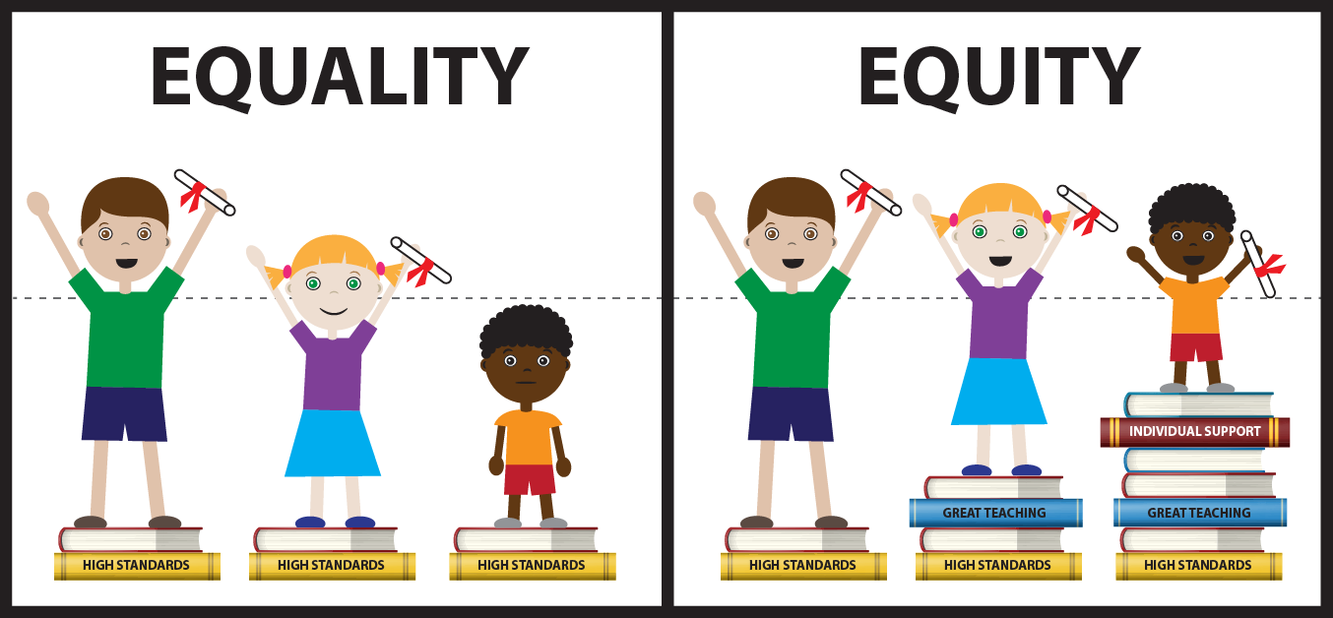

What is Meant by Assessment?
​Assessment is carried out to see what children and young people know, understand and are able to do.
Assessment is very important for tracking progress, planning next steps, reporting and involving parents, children and young people in learning.

Assessment covers:
- The ways teachers support and assess children's learning and monitor progress and identify next steps in learning.
- Reporting to parents/carers, in writing and in discussions, to help them understand their child's progress and what they can do to help their child's learning.
- Formal recognition of a child or young person's achievements through profiles and qualifications.
- Recognising our children's achievements through a range of new qualifications in the senior school, which build on everything they have accomplished throughout their schooling.

Curriculum for Excellence has improved assessment in the following ways:
- A better connected assessment system with smoother links through early learning, primary, secondary school and college.
- More ways of assessing progress to support learning and more flexibility to meet learners' individual needs.
- By introducing individual profiles of children's achievements at P7 and S3. These give a clear recognition of the achievements they have made and the skills they have developed at these crucial times in their lives.

What is Being Assessed?
Assessment is a way of supporting learning. It helps teachers, learners, parents and others to understand the depth and breadth of learning undertaken so that progress and next steps can be discussed and planned.
There are eight curriculum areas containing a range of subjects(see pg.6). Each curriculum area is broken down into a set of experiences and outcomes (often referred to as Es and Os):
- The Experience describes the learning.
- The Outcome represents what the learning will achieve. This is often explained, from the pupil's perspective as an 'I can....', 'I am able to....'

Teachers will assess what children know, understand and are able to do within the experiences and outcomes. Teachers will assess each learner's progress and achievements in:
- Knowledge and understanding
- Skills
- Attributes and capabilities
There are also three key areas which are covered by all teachers/practitioners:
- Literacy across learning
- Numeracy across learning
- Health and wellbeing across learning

How are Pupils Assessed?
A pupil’s progress is not only based on 'tests' but on the learning that takes place within the classroom and in different settings outwith the classroom.
Evidence of children and young people's progress and achievements will come from day to day learning and through the things they may write, say, make or do. For example, evidence may emerge as a result of children and young people taking part in a presentation, discussion, performance or practical investigation. Evidence could also be a drawing, report, or piece of art work that they have produced. Evidence may be captured as a photograph, video or audio clip as part of a particular learning experience.

Gathering Evidence
Evidence of progress and achievement can be gathered by:
- children and young people through self-assessment. They will be encouraged and supported to look at and revisit their own work, to develop a better understanding of what they have learned, and what they need to work on
- fellow pupils (peers) through peer assessment. Children and young people will be encouraged and supported to work together with others to assess what is good about their work and what needs to be worked on teachers, parents and others who can help identify and support their next steps in learning.

When does Assessment Happen?
Assessment takes place as part of ongoing learning and teaching, periodically and at key transitions.

As Part of Ongoing Learning
Children and young people's progress, strengths and needs are assessed as part of day-to-day learning and teaching. Teachers and others do this by, for example, watching and listening to learners carrying out tasks, by looking at what they write or make and by considering how they answer questions.
Children and young people will be involved in planning their next steps in learning.

Time to Time (periodically)
From time to time, teachers will assess children and young people's progress and achievements in order to be able to plan ahead and to record and report on progress. This will help to ensure that their progress is on track and that any necessary action is taken to support their learning.

At Key Points, Transitions
Transitions are the moves children and young people make, from home to early learning and childcare settings, from stage to stage (and through Curriculum for Excellence levels), from primary to secondary, to further or higher education and employment. Sharing of assessment information with parents is important to ensure all learners are supported and have a positive experience. Information about a learner's progress and achievements will be passed on to make sure that their broad general education and senior phase continue uninterrupted at the correct level and at an appropriate pace for them.

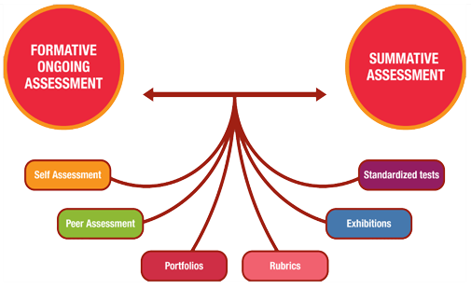

Useful Links

- GTCS Standards for Registration: http://www.gtcs.org.uk/professional-standards/standards.aspx

- SCES: http://sces.org.uk/becoming-a-teacher/

- Charter for Catholic Schools: http://sces.org.uk/charter-for-catholic-schools/

- University of Glasgow School of Education: http://www.gla.ac.uk/schools/education/

- The St Andrew’s Foundation: http://www.gla.ac.uk/schools/education/standrewsfoundation/

- Education Scotland: https://education.gov.scot/

- The RE Department Archdiocese of Glasgow: www.rercglasgow.org



@rercag @rercag @APHTAGlasgow

