Forgiving others is always hard to do when you are still feeling hurt. It takes courage—not just a warm, fuzzy feeling—to decide to forgive someone. In fact, forgiving someone shows strength of character, not weakness.
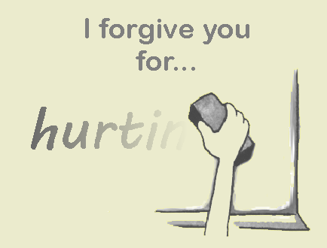
By forgiving someone, you are not saying that what the other person did is okay; but rather, that you have decided not to hold it against him/her. It may seem unfair to just let someone off without making them 'pay' for what they did. That is why it takes a special kind of love, like the love of God, to forgive.
- Forgiveness is not a feeling; it is a decision—a choice you have to make.
- God can help you forgive others. Ask Him to fill your heart with His love.
- Go to the person you need to forgive and tell him/her what made you feel sad or hurt; then let the person know that you have forgiven him/her.
- Forgiving someone may not take the hurt away immediately. It also won’t take away the memory of what happened. You may still feel sad or hurt for a while.
When it is hard to forgive
- Write on a piece of paper what happened and how that made you feel. To show that you won’t keep a record of the wrong, you could do one of the following things with that paper:
  - tear it up (or let your pet rip it to shreds);
  - soak it in water for a few minutes and then squeeze it into a tiny ball. Practice throwing the ball into a waste paper bin from a distance;
  - bury it in the garden (in a secret place);
  - think of some other unusual way to destroy it.
- Ask the Lord to help you get over the feelings of hurt.
- Any act of kindness done for the person who has been unkind will show your love in action and will help you get over your hurt more easily.
- Remember, forgiving is something you must do. The other person doesn’t need to do anything, and he doesn't owe you a favour in return. In fact, the other person might not even be sorry!
What if someone keeps hurting me?
Forgiveness does not mean that you should let the other person keep on hurting you. If someone keeps on being unkind and nasty, speak to someone you trust, or let your teacher know about the problem. Hurting others is never okay!
What if I don’t forgive?
- Your feelings for others may become unfriendly as you get angry, unforgiving thoughts.
- You will probably start to feel miserable and become crabby. But when you set someone free by forgiving them, you set yourself free to enjoy life!
- Jesus taught the disciples to pray to God in this way: “Forgive us our sins, for we also forgive everyone who sins against us”
Luke 11:4.
"If it is possible, as far as it depends on you, live at peace with everyone" Romans 12:18.

http://www.truthforkids.com/forgiving-others/#.W4ZSxehKiUk

