What Makes a Good Friend?
DISCUSSION QUESTIONS
1. What qualities do you look for in a friend?
2. Are friends more important to you now than they were in nursery school? Why?
3. There's an old saying that goes "in order to have good friends you have to be a good friend." What does that mean. Do you think it's true?
4. What's the difference between a friend and an acquaintance?
5. How do you tell the difference between true friends and false friends?
6. What is a "best friend?" Is it possible to have more than one "best friend" at the same time?
7. In what ways does friendship change as you get older?
8. Is there a difference between popularity and friendship? Can you be popular and not be a good friend? What is more important, being popular, or being a good friend?
9. Do you think there's something wrong with you if you aren't part of the popular set?
10. Some people think that popular groups are just a whole big group of false friends. What did she mean by that? Do you think it's true?
11. What do you do if you want a person you have just met to become a part of your group, but the others don't want to have anything to do with this new person?
12. Have you ever been excluded from a group? What happened? How did you feel? What should we learn from that?
13. Are all your friends the same as you? If not, In what ways are they different?
14. Are there kids here at school who get constantly excluded because they are different? How do you think that makes them feel? Is there anything you could do about it?
15. What are the benefits of having friends who are different from us?
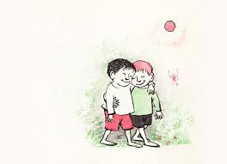
https://www.brainpickings.org/2014/01/29/lets-be-enemies-maurice-sendak/

