MAY 2021
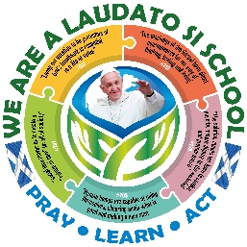
Dear Laudato Si’ Schools,

Thank you for making your promise to love God, look after each other and protect the world. It has been great to see all of your updates and posts on Twitter and Facebook, thanks for tagging SCES so that we didn’t miss them.

At the end of May of this year the Pope is hosting Laudato Si’ Week, to bring to an end the special anniversary year. In November 2021 it is possible that the Holy Father will visit Scotland to attend the COP 26 summit in Glasgow!

UPDATE FOR THE POPE:
We would like to gather all of the news from the Laudato Si’ Schools in Scotland and send them to Pope Francis to let him know the work that has already started here.

In order to ensure that we don’t miss any of the work from your school, could I ask you to tell us all of the things that you are already doing, using the first page that follows, and send this to me by Friday 12th June.
If you are able to complete any of the other questions, we would love to hear about them too, but for this year if you are only able to answer the first question, that is plenty!

Laudato Si’ Scotland Prayer, Artwork and Song:
In addition to sharing all you are doing as a Laudato Si’ school with the Pope, we would also like to ask for your help in preparing for the World Leaders coming to Glasgow for the Global COP26 conference in November. For their visit, we would like to have a schools’ prayer for Laudato Si’ Schools Scotland. We would also love to have some original art work by pupils and a song celebrating how our schools are promising to look after God’s earth and all of the people on it.

We would therefore like to invite all pupils to write either a song (don’t worry If you are not musical, just write the lyrics and we will get some help to write music for the one that we choose to be our Scottish Laudato Si’ song.) create a piece of original art work or write a prayer, based on their learning, prayer and action as a Laudato Si’ School.

We would then invite each schools to send all of their art work as digital images and to decide which one song and one prayer they would like to send to SCES by September 30th 2021. Once we have received them all we will create a virtual art exhibition, a prayer resource AND we will ask some musical friends to help us choose one song to become our Laudato Si’ Schools Scotland anthem!

We know how buy school life is at the moment, and so we know that you may only have time to send us the bullet points of what you are doing.

If you have any questions about Laudato Si’ Schools Scotland, please do not hesitate to contact me. With every good wish for a happy and holy Easter,
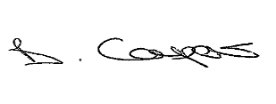
School Name & town:
Please return by 30th April
1.What are we doing?
Make a list of bullet points of ALL the things that you are doing in your school: (recycling, walking to school, food waste reuction, prayers and assemblies, environmental work in class, charity fund raising for those in poverty etc)

Choose one or two things on your list above, something that you would really like the Pope to know about, and tell us some details about them: (use a new page if you need to).

Please return by 30th Sept
Please share the Laudato Si’ prayer written by your school here:
Our Laudato Si’ School Prayer

Please return by 30th Sept
Please share the Laudato Si’ song lyrics written by your school here:

Our Laudato Si’ Song Lyrics

Please do not feel obliged to feedback on any other questions. The idea is that you build your work over a number of years. So, only answer the following questions if you have had time to think about them as a Laudato Si’ school.
Have you thought of any ideas or do you have plans for more things to do in the future? List them below:
2.What more can we do?

From your question 1. have you thought of ways to keep these initiatives going?
3.How can we maintain this?

4.How can we share this?
How have you been telling others about being a Laudato Si’ School? (Social Media, assemblies, parents’ evenings, newsletters) Who have you been telling? (Local councillors, parishioners, families, local newspaper, SCES, SCIAF, Justice & Peace Scotland, the Diocese, your MSP?)

5.What is the impact?
What has changed because f your prayer, learning and action? What good has come from all your work? (think about your own school, families, local community, parish, country, people in other parts of the world)

