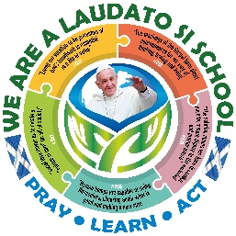
MAY 2021
Dear Laudato Si’ Schools,

Thank you for making your promise to love God, look after each other and protect the world. It has been great to see all of your updates and posts on Twitter and Facebook, thanks for tagging SCES so that we didn’t miss them.

At the end of May of this year the Pope is hosting Laudato Si’ Week, to bring to an end the special anniversary year. In November 2021 it is possible that the Holy Father will visit Scotland to attend the COP 26 summit in Glasgow!

UPDATE FOR THE POPE:
We would like to gather all of the news from the Laudato Si’ Schools in Scotland and send them to Pope Francis to let him know the work that has already started here.

In order to ensure that we don’t miss any of the work from your school, could I ask you to tell us all of the things that you are already doing, using the first page that follows, and send this to me by Friday 12th June.
If you are able to complete any of the other questions, we would love to hear about them too, but know that for this year you may only able to answer the first question.

Laudato Si’ Scotland Artwork and Political Engagement for COP26:
In addition to sharing all you are doing as a Laudato Si’ school with the Pope, we would also like to ask for your help in preparing for the World Leaders coming to Glasgow for the Global COP26 conference in November. For their visit, SCES has applied to have pupils attend the conference on 2 days to share their experience of climate change, poverty and the environment. For this we will be creating videos, interviewing schools and we would like to display some original art work by pupils based on the Encyclical.

We would therefore like to invite all schools to encourage pupils to create a piece of original art work based on their learning, prayer and action as a Laudato Si’ School. We invite each school to send all of their art work as digital images to SCES by September 30th 2021. Once we have received them all we will create a virtual art exhibition for the COP26 conference and we may ask for some of the original pieces to frame and display.

We would also like to collate questions that senior pupils want to pose to our local, national and UK politicians based on the Pope’s call to action as we are also planning to host an event with politicians for senior phase pupils. At this event pupils will be able to ask questions about each political party’s action to tackle poverty and challenge climate change.

We know how busy school life is at the moment, and so we know that you may only have time to send us the bullet points of what you are doing. We are grateful for any update that you can send.

If you have any questions about Laudato Si’ Schools Scotland, please do not hesitate to contact me. With every good wish for a happy and holy Easter,

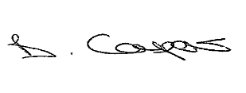

School Name & town:
Please return by 12th June 2021
1.What are we doing?
Make a list of bullet points of ALL the things that you are doing in your school: (recycling, walking to school, food waste reuction, prayers and assemblies, environmental work in class, charity fund raising for those in poverty etc)

Choose one or two things on your list above, something that you would really like the Pope to know about, and tell us some details about them: (use a next page if you need to).

Please share the questions that your senior phase pupils have for politicians on the issues of poverty, climate change, the environment.
Our Laudato Si’ Questions for politicians
Please return by 30th June 2021

Please do not feel obliged to feedback on any other questions. The idea is that you build your work over a number of years. So, only answer the following questions if you have had time to think about them as a Laudato Si’ school.
Have you thought of any ideas or do you have plans for more things to do in the future? List them below:
2.What more can we do?

From your question 1. have you thought of ways to keep these initiatives going?
3.How can we maintain this?

4.How can we share this?
How have you been telling others about being a Laudato Si’ School? (Social Media, assemblies, parents’ evenings, newsletters) Who have you been telling? (Local councillors, parishioners, families, local newspaper, SCES, SCIAF, Justice & Peace Scotland, the Diocese, your MSP?)

5.What is the impact?
What has changed because f your prayer, learning and action? What good has come from all your work? (think about your own school, families, local community, parish, country, people in other parts of the world)

