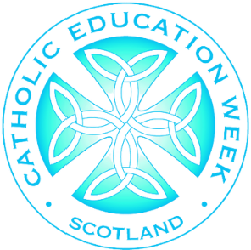
Use this space to add details of your event. An example programme has been added as a suggestion.
0830 | Breakfast
0900 | Welcome and introduction from Pupil Chaplaincy Team/SLT/HT/Caritas/PFFA/RE Coordinator.
0915 | Morning offering lead by learners.
0925 | Short presentation on history and identity of Catholic Education (see CEW speaker notes).
0945 | Day 9 of Novena to St Margaret of Scotland.
0955 | Close and Thanks.
1000 | Optional for those able to stay; tea/coffee, tour and learner showcase.
SAMPLE PROGRAMME
‘Pilgrims of Faith’
@scesdirector
#CEWPrayerBreakfast
#PilgrimsOfFaith

Catholic Education Week
Prayer Breakfast


and invite you to our
Our School are celebrating

