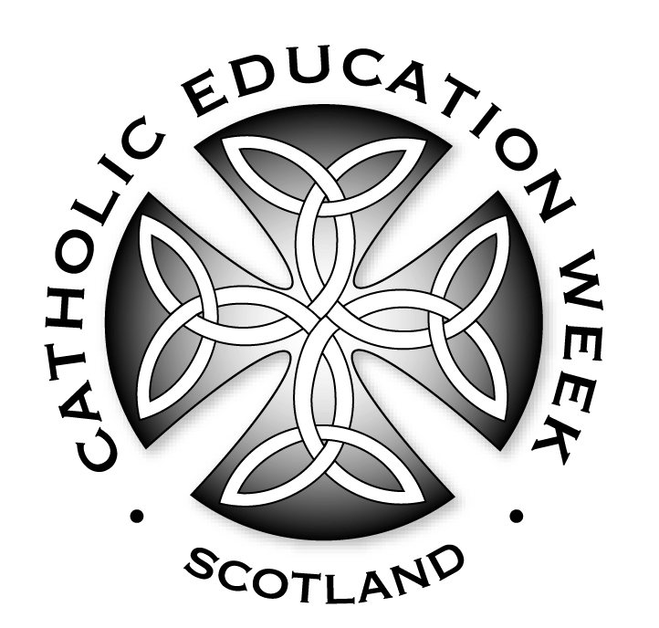
Prayers of Intercession

Celebrant: Gathered as one to celebrate as a community of faith and learning, let us ask God our Father to prompt in us prayers that are worthy of his hearing.

For the Church throughout the world:
that as a community of faith, she may witness to your presence in every corner of the world. Lord Hear Us.

For Pope Francis, our Bishops, priests, religious and deacons:
that they will bring our world to know God’s love as they lead our communities of faith. Lord Hear Us.
For all who hold positions of leadership in our country:
that they will value the importance of providing the highest quality of education for all young people. Lord Hear Us.

For parents and carers:
that, as the first teachers of their children, the home will be where children will learn to love their neighbour as themselves. Lord Hear Us.

For teachers and catechists who form young people in faith:
that they will be inspired by the Holy Spirit to communicate Catholic Social Teaching, and promote social justice by word and example. Lord Hear Us.

For all children and young people:
that they will become disciples of Jesus and fulfil the potential of their God given talents. Lord Hear Us.
For all who are sick:
that they will come to know the healing power of God’s love. Lord Hear Us.

For those who have died:
that they will enjoy happiness for eternity. Lord Hear Us.
Celebrant: Father, you invite us to know you, to love you and to serve you. Help us to witness joyfully to faith in you, through our words and actions. We ask this through our Lord Jesus Christ, your Son, who lives and reigns with you and the Holy Spirit, one God, for ever and ever. Amen.

