13th March 2017

Dear head teachers,
In 2018 we will reach the centenary of the 1918 Education Act. This was the Act that saw Catholic schools transfer from Diocesan control to State governance. The Bishops’ Conference has authorised the Scottish Catholic Education Service (SCES) to propose plans to use this centenary to celebrate the positive impact that this very important partnership between Church and State has had for Scotland.
2018 serves as an opportunity to rejoice in the academic, cultural, civic and social achievements of pupils who have attended Catholic schools in the last one hundred years. It is a chance to mark publicly the ways in which Catholic schools are not just good for Catholics, but good for Scotland.
The positive contribution of Catholic schools to Scottish society is well documented. The continuing support of Scottish Government and all of the main political parties is encouraging for the future of denominational schools. However, while this is a time to reflect and thank God for one hundred years of serving our local communities, we cannot be complacent that there is universal support for Catholic schools. We need to ensure that we continue to challenge the negative voices which exert pressure in the media and in the political arena, suggesting that there is no place for faith schools in the public provision of education in a modern Scotland. What better way to do this than by marking this centenary as a celebration of the distinctive nature of our schools and by telling the story of the people and communities who have benefited from Catholic education in Scotland!
A planning group has been established to consider potential activities and to co-ordinate events. I would like to invite all parishes, families, schools and communities to begin to consider the ways that they can add to this story. I have included an update from the planning group and I would ask you to bring this to the attention of your parent and pupil councils, pastoral planning team and your associated schools’ group. I encourage you to begin a discussion of how your local parish community can support and contribute to the events of this year.

The Scottish Catholic Education Service will keep you up to date with information regarding National and Diocesan events. In the meantime, SCES would welcome any archive material that you have regarding the history of your local schools, or any interesting stories and photographs from parishioners. If you plan to host an event, please let SCES know so that they can support it through advertising and add it to the calendar of events for your Diocese.
Yours devotedly in Christ,

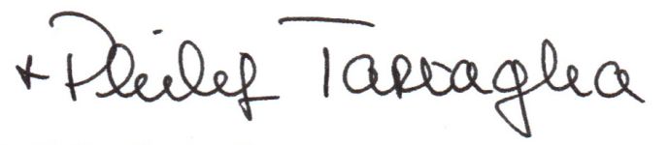
Philip Tartaglia, Archbishop of Glasgow
Bishop-President of the Executive of the Scottish Catholic Education Service

