SCOTTISH CATHOLIC EDUCATION SERVICE

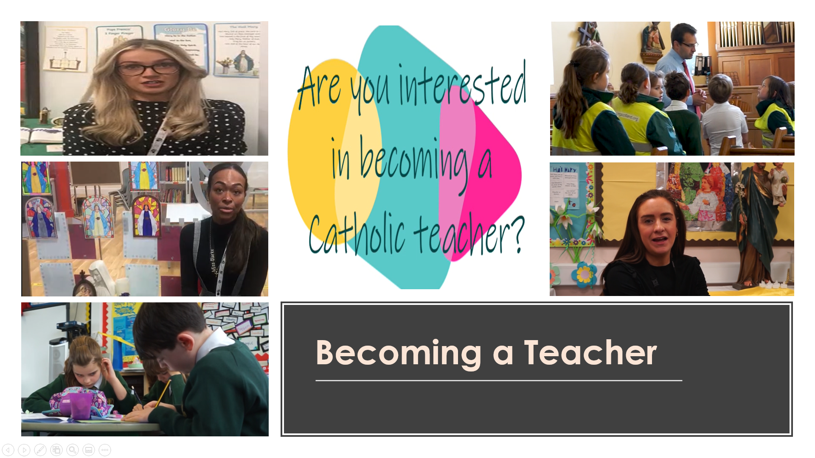

Reading and Reflection Materials for Aspiring Teachers
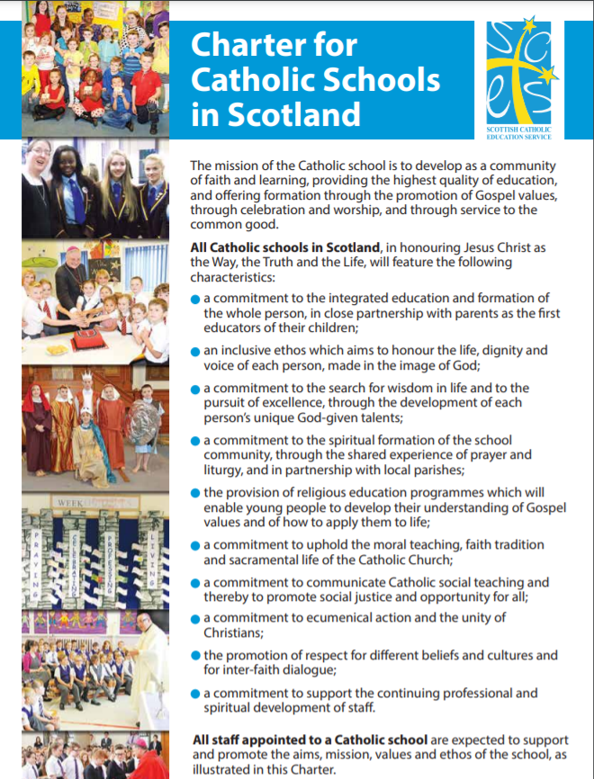

Reading and Reflection Materials for Aspiring Teachers

Section 1 – Church Documents

“Lay Catholics in School: Witnesses to Faith”
The Sacred Congregation for Catholic Education, October 1982
https://www.vatican.va/roman_curia/congregations/ccatheduc/documents/rc_con_ccatheduc_doc_19821015_lay-catholics_en.html

“Lay Catholics, both men and women, who devote their lives to teaching in primary and secondary schools, have become more and more vitally important in recent years. Whether we look at schools in general, or Catholic schools in particular, the importance is deserved.
For it is the lay teachers, and indeed all lay persons, believers or not, who will substantially determine whether or not a school realises its aims and accomplishes its objectives. In the Second Vatican Council, and specifically in the Declaration on Christian Education, the Church recognised the role and the responsibility that this situation confers on all those lay Catholics who work in any type of elementary and secondary schools, whether as teachers, directors, administrators, or auxiliary staff. The Declaration invites us to expand on its contents and deepen them; in doing this, it is not our intention to ignore or minimise the significant accomplishments of Christians who belong to other Churches, or of non-Christians, in the field of education.” (1)

“The cultural level has progressively risen; because this is closely tied to advances in science and technology, every profession requires a more extensive preparation. To this must be added a more general awareness of the fact that every person has a right to an integral education, an education which responds to all of the needs of the human person. . .
The Church believes that, for an integral education of children and young people, both Religious and lay Catholics are needed in the schools.” (3)

“The evangelisation of the world involves an encounter with such a wide variety and complexity of different situations that very frequently, in concrete circumstances and for most people, only the laity can be effective witnesses of the Gospel. Therefore, "the laity are called in a special way to make the Church present and operative in those places and circumstances where only through them can she become the salt of the earth ". In order to achieve this presence of the whole Church, and of the Saviour whom she proclaims, lay people must be ready to proclaim the message through their words, and witness to it in what they do.
Because of the experiences that lay people acquire in their lives, and through their presence in all of the various spheres of human activity, they will be especially capable of recognising and clarifying the signs of the times that characterise the present historical period of the People of God. Therefore, as a proper part of their vocation, they should contribute their initiative, their creativity, and their competent, conscious, and enthusiastic labour to this task. In this way, the whole People of God will be able to distinguish more precisely those elements of the signs that are Gospel values, or values contrary to the Gospel.” (9 & 10)

“The function exercised by the school in society has no substitute; it is the most important institution that society has so far developed to respond to the right of each individual to an education and, therefore, to full personal development; it is one of the decisive elements in the structuring and the life of society itself. In today's world, social interchange and mass media grow in importance (and their influence is sometimes harmful or counter-productive); the cultural milieu continues to expand; preparation for professional life is becoming ever more complex, more varied, and more specialized. The family, on its own, is less and less able to confront all of these serious problems; the presence of the school, then, becomes more and more necessary.” (13)

“The teacher under discussion here is not simply a professional person who systematically transmits a body of knowledge in the context of a school; "teacher" is to be understood as "educator" - one who helps to form human persons. The task of a teacher goes well beyond transmission of knowledge, although that is not excluded. Therefore, if adequate professional preparation is required in order to transmit knowledge, then adequate professional preparation is even more necessary in order to fulfil the role of a genuine teacher. It is an indispensable human formation, and without it, it would be foolish to undertake any educational work.
One specific characteristic of the educational profession assumes its most profound significance in the Catholic educator: the communication of truth. For the Catholic educator, whatever is true is a participation in Him who is the Truth; the communication of truth, therefore, as a professional activity, is thus fundamentally transformed into a unique participation in the prophetic mission of Christ, carried on through one's teaching.
The integral formation of the human person, which is the purpose of education, includes the development of all the human faculties of the students, together with preparation for professional life, formation of ethical and social awareness, becoming aware of the transcendental, and religious education. Every school, and every educator in the school, ought to be striving " to form strong and responsible individuals, who are capable of making free and correct choices ", thus preparing young people " to open themselves more and more to reality, and to form in themselves a clear idea of the meaning of life ".” (16 & 17)

“Conduct is always much more important than speech; this fact becomes especially important in the formation period of students. The more completely an educator can give concrete witness to the model of the ideal person that is being presented to the students, the more this ideal will be believed and imitated. For it will then be seen as something reasonable and worthy of being lived, something concrete and realisable. It is in this context that the faith witness of the lay teacher becomes especially important. Students should see in their teachers the Christian attitude and behaviour that is often so conspicuously absent from the secular atmosphere in which they live. Without this witness, living in such an atmosphere, they may begin to regard Christian behaviour as an impossible ideal. It must never be forgotten that, in the crises " which have their greatest effect on the younger generations ", the most important element in the educational endeavour is " always the individual person: the person, and the moral dignity of that person which is the result of his or her principles, and the conformity of actions with those principles ".” (32)

“In this context, what was said above about direct and personal contact between teachers and students becomes especially significant: it is a privileged opportunity for giving witness. A personal relationship is always a dialogue rather than a monologue, and the teacher must be convinced that the enrichment in the relationiship is mutual. But the mission must never be lost sight of: the educator can never forget that students need a companion and guide during their period of growth; they need help from others in order to overcome doubts and disorientation. Also, rapport with the students ought to be a prudent combination of familiarity and distance; and this must be adapted to the need of each individual student. Familiarity will make a personal relationship easier, but a certain distance is also needed: students need to learn how to express their own personality without being pre-conditioned; they need to be freed from inhibitions in the responsible exercise of their freedom.” (33)
“The family is " the first and fundamental school of social living” therefore, there is a special duty to accept willingly and even to encourage opportunities for contact with the parents of students. These contacts are very necessary, because the educational task of the family and that of the school complement one another in many concrete areas; and they will facilitate the " serious duty " that parents have " to commit themselves totally to a cordial and active relationship with the teachers and the school authorities ". Finally, such contacts will offer to many families the assistance they need in order to educate their own children properly; and thus fulfil the " irreplaceable and inalienable " function that is theirs.” (34)

“As a visible manifestation of the faith they profess and the life witness they are supposed to manifest, it is important that lay Catholics who work in a Catholic school participate simply and actively in the liturgical and sacramental life of the school. Students will share in this life more readily when they have concrete examples: when they see the importance that this life has for believers. In today's secularised world, students will see many lay people who call themselves Catholics, but who never take part in liturgy or sacraments. It is very important that they also have the example of lay adults who take such things seriously, who find in them a source and nourishment for Christian living.” (40)

“ . . .while Catholic educators will teach doctrine in conformity with their own religious convictions and in accord with the identity of the school, they must at the same time have the greatest respect for those students who are not Catholics. They should be open at all times to authentic dialogue, convinced that in these circumstances the best testimony that they can give of their own faith is a warm and sincere appreciation for anyone who is honestly seeking God according to his or her own conscience.” (42)

THE CATHOLIC SCHOOL ON THE THRESHOLD OF THE THIRD MILLENNIUM
The Sacred Congregation for Catholic Education, December 1997
https://www.vatican.va/roman_curia/congregations/ccatheduc/documents/rc_con_ccatheduc_doc_27041998_school2000_en.html

“. . . it is opportune to devote careful attention to certain fundamental characteristics of the Catholic school, which are of great importance if its educational activity is to be effectual in the Church and in society. Such are: the Catholic school as a place of integral education of the human person through a clear educational project of which Christ is the foundation; its ecclesial and cultural identity; its mission of education as a work of love; its service to society; the traits which should characterise the educating community.” (4)
“Thus the Catholic school should be able to offer young people the means to acquire the knowledge they need in order to find a place in a society which is strongly characterized by technical and scientific skill. But at the same time, it should be able, above all, to impart a solid Christian formation.” (8)
“Attention is rightly given to the importance of the relations existing between all those who make up the educating community. During childhood and adolescence a student needs to experience personal relations with outstanding educators, and what is taught has greater influence on the student's formation when placed in a context of personal involvement, genuine reciprocity, coherence of attitudes, life-styles and day to day behaviour. While respecting individual roles, the community dimension should be fostered, since it is one of the most enriching developments for the contemporary school.” (18)
“In the Catholic school, "prime responsibility for creating this unique Christian school climate rests with the teachers, as individuals and as a community".(24) Teaching has an extraordinary moral depth and is one of man's most excellent and creative activities, for the teacher does not write on inanimate material, but on the very spirits of human beings. The personal relations between the teacher and the students, therefore, assume an enormous importance and are not limited simply to giving and taking. Moreover, we must remember that teachers and educators fulfil a specific Christian vocation and share an equally specific participation in the mission of the Church, to the extent that "it depends chiefly on them whether the Catholic school achieves its purpose".” (19)

THE RELIGIOUS DIMENSION OF EDUCATION IN A CATHOLIC SCHOOL
GUIDELINES FOR REFLECTION AND RENEWAL
The Congregation for Catholic Education, April 1988
https://www.vatican.va/roman_curia/congregations/ccatheduc/documents/rc_con_ccatheduc_doc_19880407_catholic-school_en.html

“Not all students in Catholic schools are members of the Catholic Church; not all are Christians. There are, in fact, countries in which the vast majority of the students are not Catholics - a reality which the Council called attention to. The religious freedom and the personal conscience of individual students and their families must be respected, and this freedom is explicitly recognised by the Church. On the other hand, a Catholic school cannot relinquish its own freedom to proclaim the Gospel and to offer a formation based on the values to be found in a Christian education; this is its right and its duty.” (6)

“Everyone directly involved in the school is a part of the school community: teachers, directors, administrative and auxiliary staff. Parents are central figures, since they are the natural and irreplaceable agents in the education of their children. And the community also includes the students, since they must be active agents in their own education.” (32)

“Students spend a large share of each day and the greater part of their youth either at school or doing activities that are related to school. "School" is often identified with "teaching"; actually, classes and lessons are only a small part of school life. Along with the lessons that a teacher gives, there is the active participation of the students individually or as a group: study, research, exercises, para-curricular activities, examinations, relationships with teachers and with one another, group activities, class meetings, school assemblies. While the Catholic school is like any other school in this complex variety of events that make up the life of the school, there is one essential difference: it draws its inspiration and its strength from the Gospel in which it is rooted.” (47)

EVANGELII NUNTIANDI: ON EVANGELISATION IN THE MODERN WORLD”
Pope Paul VI, December 8, 1975

“Above all the Gospel must be proclaimed by witness. Take a Christian or a handful of Christians who, in the midst of their own community, show their capacity for understanding and acceptance, their sharing of life and destiny with other people, their solidarity with the efforts of all for whatever is noble and good. Let us suppose that, in addition, they radiate in an altogether simple and unaffected way their faith in values that go beyond current values, and their hope in something that is not seen and that one would not dare to imagine. Through this wordless witness these Christians stir up irresistible questions in the hearts of those who see how they live: Why are they like this? Why do they live in this way? What or who is it that inspires them? Why are they in our midst? Such a witness is already a silent proclamation of the Good News and a very powerful and effective one.” (21)

“Modern man listens more willingly to witnesses than to teachers, and if he does listen to teachers, it is because they are witnesses.” (41)

SECTION 2: PAPAL ADDRESSES

“In your school you take part in various activities that habituate you not to shut yourselves in on yourselves or in your small world, but to be open to others, especially to the poorest and neediest, to work to improve the world in which we live. Be men and women with others and for others, real champions in the service of others. To be magnanimous with interior liberty and a spirit of service, spiritual formation is necessary. Dear children, dear youths, love Jesus Christ ever more!” (Pope Francis, meeting with Students of Jesuit Schools, 2013)

“Education cannot be neutral. It is either positive or negative; either it enriches, or it impoverishes; either it enables a person to grow or it lessens, even corrupts him. The mission of schools is to develop a sense of truth, of what is good and beautiful. And this occurs through a rich path made up of many ingredients. This is why there are so many subjects - because development is the results of different elements that act together and stimulate intelligence, knowledge, the emotions, the body, and so on.” (Pope Francis, Address with Italian school teachers, parents, educators, pupils and other workers, May 10, 2014)

“I know that there are many non-Catholics studying in the Catholic schools in Great Britain, and I wish to include all of you in my words today. I pray that you too will feel encouraged to practise virtue and to grow in knowledge and friendship with God alongside your Catholic classmates. You are a reminder to them of the bigger picture that exists outside the school, and indeed, it is only right that respect and friendship for members of other religious traditions should be among the virtues learned in a Catholic school. I hope too that you will want to share with everyone you meet the values and insights you have learned through the Christian education you have received.”
(Pope Benedict XVI, Address to Teachers and Religious, Twickenham, 2010)

“The task of a teacher is not simply to impart information or to provide training in skills intended to deliver some economic benefit to society; education is not and must never be considered as purely utilitarian. It is about forming the human person, equipping him or her to live life to the full, in short it is about imparting wisdom. And true wisdom is inseparable from knowledge of the Creator, for “both we and our words are in his hand, as are all understanding and skill in crafts (Wis 7:16).” (Pope Benedict XVI, Address to Teachers and Religious, Twickenham, 2010)

“A good school provides a rounded education for the whole person. And a good Catholic school, over and above this, should help all its students to become saints.” (Pope Benedict XVI, Address to Teachers and Religious, Twickenham, 2010)

“Educating, from the Latin educere, means leading young people to move beyond themselves and introducing them to reality, towards a fullness that leads to growth. This process is fostered by the encounter of two freedoms, that of adults and that of the young. It calls for responsibility on the part of the learners, who must be open to being led to the knowledge of reality, and on the part of educators, who must be ready to give of themselves. For this reason, today more than ever we need authentic witnesses, and not simply people who parcel out rules and facts; we need witnesses capable of seeing farther than others because their life is so much broader. A witness is someone who first lives the life that he proposes to others.” (Pope Benedict XVI, World Day Of Peace Message, 2012)

“ … no Catholic school can be effective without dedicated Catholic teachers, convinced of the great ideal of Catholic education. The Church needs men and women who are intent on teaching by word and example – intent on helping to permeate the whole educational milieu with the spirit of Christ.” (Message of Pope John Paul II to the National Catholic Educational Association of the United States, 1979)

“Catholic education is above all a question of communicating Christ, of helping to form Christ in the lives of others.” (Message of Pope John Paul II to the National Catholic Educational Association of the United States, 1979)

“The life of a teacher, as I know from personal experience, is very challenging and demanding, but it is also profoundly satisfying. It is more than a job, for it is rooted in our deepest convictions and values. To be intimately concerned in the development of a young person, of hundreds of young people, is a highly responsible task. As teachers, you kindle in your students a thirst for truth and wisdom. You spark off in them a desire for beauty. You introduce them to their cultural heritage. You help them to discover the treasures of other cultures and peoples. What an awesome responsibility and privilege is yours in the teaching profession.” (Address of John Paul II to the Council, Staff, and Students of the Institute of Catholic Education, Melbourne,1986)

“Catholic education aims not only to communicate facts, but also to transmit a coherent, comprehensive vision of life, in the conviction that the truths contained in that vision liberate students in the most profound meaning of human freedom.” (Address of Pope John Paul II to the Bishops of the Ecclesiastical Regions of Chicago, Indianapolis, and Milwaukee, 1998)

“Perhaps we could reflect on the philosophy behind education: education as the completing of the person. To be educated is to be more fitted for life; to have a greater capacity for appreciating what life is, what it has to offer, and what the person has to offer in return to the wider society of man. Thus, if we would apply our modern educational skills and resources to this philosophy, we might succeed in offering something of lasting value to our pupils and students, an antidote to often immediate prospects of frustration and boredom, not to mention the uncertainty of the long-term future.” (Address of Pope John Paul II to the Staff and Students of St. Andrew’s College, Glasgow, June 1982)

SECTION 3 – EDUCATION DOCUMENTS

“All Catholic teachers are called to model themselves on Jesus the supreme teacher . . . As those who model themselves on Christ, teachers should first and foremost take time to reflect on their own faith journey, seeking strength in the Holy Spirit to inspire their own faith commitment and to develop their own understanding of the person and teachings of Christ. There is humility in this, recognising that although teachers have much to teach the next generation and, more specifically, Jesus’ young disciples today, they themselves remain disciples of the one Teacher, who leads all deeper into truth.” (“This is our Faith”, Scottish Catholic Education Service (on behalf of the Bishops’ Conference of Scotland), p.58)

“Catholic schools welcome all their students as members of the school community. This is evident in the way that all are valued, treated with respect and encouraged to participate fully in the life of the school. This includes appropriate participation in both religious observance and religious education as well as in other activities which stem from the faith mission of the school, e.g., charitable fund-raising, service to the community and other faith witness activities. Teachers are expected to bear witness to this attitude of respect for, and appreciation of, all people including those of other Christian denominations, other faiths, and stances for living which may be independent of religious belief.” (“This is our Faith”, Scottish Catholic Education Service (on behalf of the Bishops’ Conference of Scotland), p.9)

“In summary, a Catholic school is expected by the Church to be a community of faith and learning which helps young people to come to know Jesus Christ as the Son of God, to become familiar with His teaching and to use their own talents in order to give personal witness to Him in their daily lives.” (“The Catholic School: Developing in Faith”, Scottish Catholic education Service, p.3)

“Teaching in Catholic schools offers opportunities for catechesis and requires teachers to be confident communicators of the beliefs and values of Catholic Christianity. Very often, teachers are regarded by children, young people and parents as witnesses to faith, expected to offer guidance on moral and social issues, and also to offer support and counsel to their students. Teachers are also regarded as people of integrity who try to reflect in their personal lives the virtues, values and beliefs which they espouse.” (“Companions on the Journey”, Scottish Catholic Education Service, p.4)

“In Catholic schools it is critical that the professional dialogue which is at the centre of the PRD process includes consideration of the impact of each teacher’s professional development on the Catholic school community, and on the delivery of its vision, aims, values and ethos.” (“The Catholic School: Developing in Faith”, Scottish Catholic education Service, p.3)

“Scotland in the 21st century is an increasingly multi-cultural and diverse nation. The great majority of Scottish denominational schools are Roman Catholic, while a small number serve other faith communities. The curriculum in a denominational school will reflect its particular faith perspective. In Roman Catholic schools, it will build on the openness of Catholic schools to other young people regardless of denominations and faiths.” (Religious Education in Roman Catholic Schools: Principles and Practice, Education Scotland, p.1)

“As many schools and teachers recognise, the curriculum is more than curriculum areas and subjects: it is the totality of experiences which are planned for children and young people through their education – a canvas upon which their learning experiences are formed. Learning through religious education in Roman Catholic schools is no exception, contributing to the four aspects of the curriculum from Progress and Proposals: the ethos and life of the school, interdisciplinary studies, curriculum areas and subjects, and opportunities for personal achievement.” (Religious Education in Roman Catholic Schools: Principles and Practice, Education Scotland, p.1)

“The process of learning in religious education in the Catholic school can be seen as a journey of faith, a quest for personal growth and response within the community of faith. To ensure that the young person is able to participate fully and actively in this journey, it is essential that they are accompanied by adults who can engage, question and explain in such a way that the young person is enabled to reflect, understand deeply and respond appropriately.” (Religious Education in Roman Catholic Schools: Principles and Practice, Education Scotland, p.2)

“An excellent Catholic teacher is nourished by a personal relationship with Jesus Christ which inspires living a life of integrity, fidelity and holiness. A teacher gives authentic witness to this relationship through faithful participation in the sacramental life of the Church and joyful Christian living. The role of an excellent Catholic teachers is to witness by: testifying to a relationship with Jesus Christ through words and actions ; modelling fidelity to truth and virtuous behaviour; sharing authentically his or her journey of faith; living a life of joy and hope.” (“The Excellent Catholic Teacher”, Council of Catholic School Superintendents of Alberta )

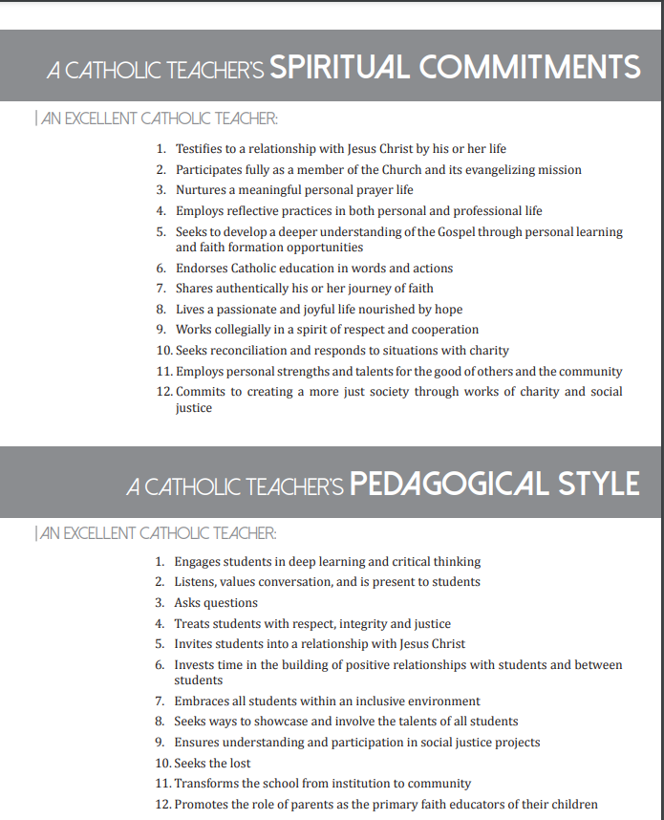
Taken from (“The Excellent Catholic Teacher”, Council of Catholic School Superintendents of Alberta )

