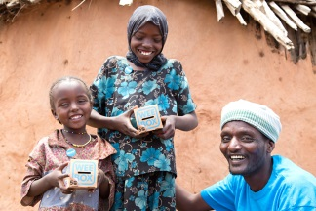 | Hello! My name is … and I’m going to present SCIAF’s WEE BOX assembly.  The photos and the people you’ll see in this presentation live in Borana in the south of Ethiopia.
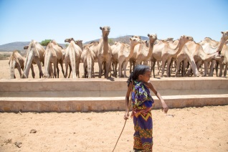 | In Borana many families live a traditional life of herding and selling animals. Cows, goats and camels are like currency and the more you have it shows how wealthy your family are.
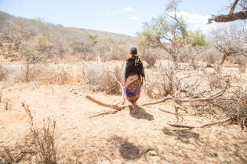 | For generations, the people in Borana have lived in harmony with the land. But drought is making the pasture scarce and animals are dying.
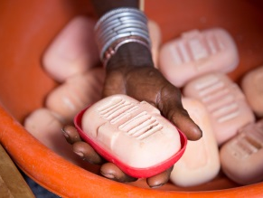 | Together, with SCIAF we’re helping people learn new skills, like soap making, so they can earn money. These women have learned how to make soap using locally grown aloe. They now sell the soap at market and to a local shop.
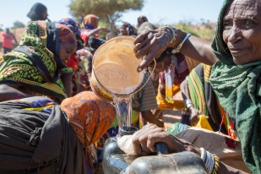 | We’re helping communities in Borana to protect their herds and pasture from the changing climate by making sure they have enough clean, safe water all year round.
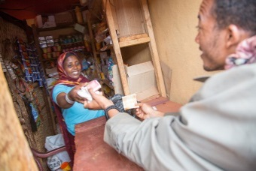 | We’re also teaching people business skills and giving them a loan so they can set up their own small business.
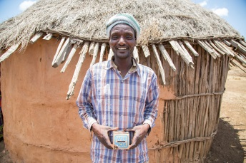 | This is Carfi Sara. Carfi and his family live a traditional life of herding and selling animals. The Sara family are featured on your WEE BOX this year.
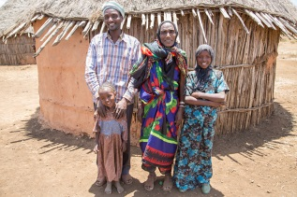 | Carfi and his wife have 3 children. This a picture of Carfi, his two daughters, Loko aged 12 and Dabo aged 4, and their Grandmother.
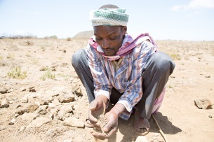 | When drought killed the family’s cattle in 2011, they were left with nothing. They were often hungry and were struggling to survive.
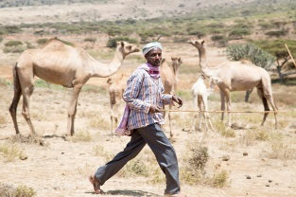 | With your help, Carfi was given eight goats, a camel and a donkey to replace the animals that had died.
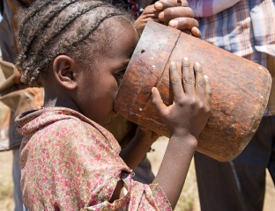 | Now, thanks to you, his family have plenty of goat and camel milk to drink and even extra to sell at market.
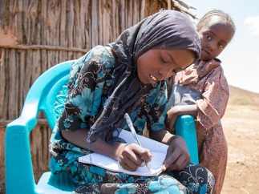 | With the money Carfi earns selling milk he can buy food and grain to feed his family. He’s also bought a uniform and shoes so his oldest daughter, Loko, can go to school.
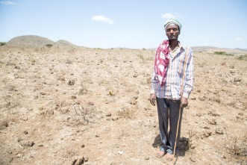 | Carfi told us “Before, I was paralysed by poverty. Now, I can’t believe how different life is for me and my family.”
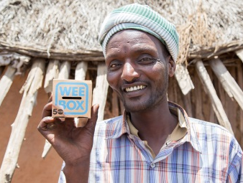 | Carfi is a generous man. He also shares what he has with his neighbours. He told us “When they ask me, I give to the poor, please do the same. Together, we can make people strong.” After being shown mercy, he too, has shown mercy and is helping others in need.
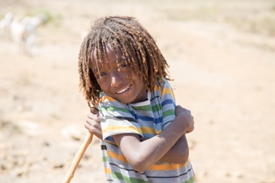 | It is often the case that when people have been helped, they too help others. Let us remember and reflect on Carfi’s actions during this Year of Mercy.
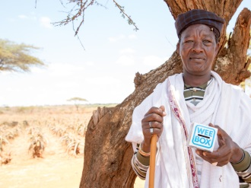 | This Lent, your donations and prayers will help lots more families like Carfi’s to build a better future for themselves and their children.
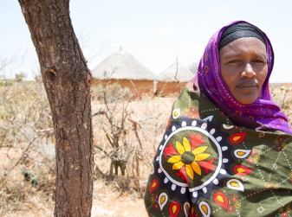 | Loving God, whose son Jesus Christ  called all who were thirsty  to come to him, believe and drink.  Look in mercy on your people living in dry lands, and  struggling to survive without safe drinking water.  Forgive our selfishness in life and our misuse of  our natural resources.  We commit ourselves to value and care for your gifts to us.  May rivers of living water  and practical compassion for all who  suffer flow out from our hearts.  Refreshed by your Spirit,  and following in the way of Jesus Christ,  help us continue to serve you and the people and creation  entrusted to our care.  Amen
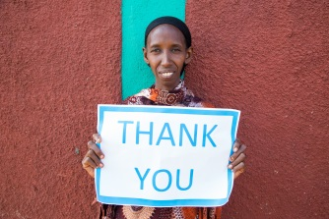 | Thank you

