Susan feels uncomfortable when she is sitting next to a muslim woman wearing a burka on the train.  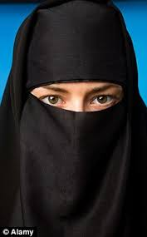 | 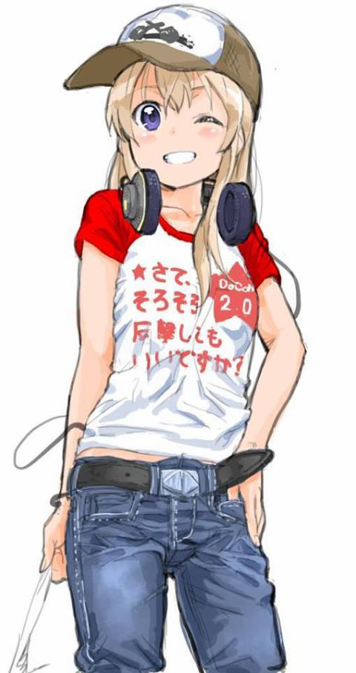  Sally has always been a bit of a tomboy and now her classmates have started to call her gay.
Martin went for a job interview and was more than qualified. He was told he didn’t get it because they were looking for someone younger.  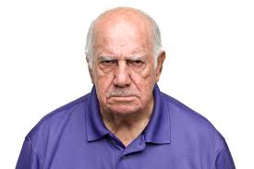 |   Steven gets beaten up on a night out because of the colour of his skin. He was called racist names during the attack.
Carol thinks her friend Sarah won’t be able to take part in the school sports day because she is in a wheelchair.  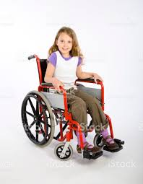 | Angela gets turned down for an apprenticeship to be a mechanic. The employer tells her to consider a more feminine career.  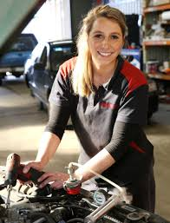
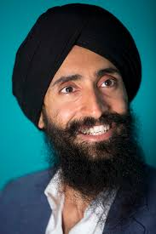  Sadhik, a Sikh man, always gets stopped and searched going through airport security. People often shout that he is a terrorist because of the way he looks. |   Amanda feels uncomfortable being treated by the new nurse in the surgery because he is a man. She doesn’t think he’ll be as good as a female nurse.

