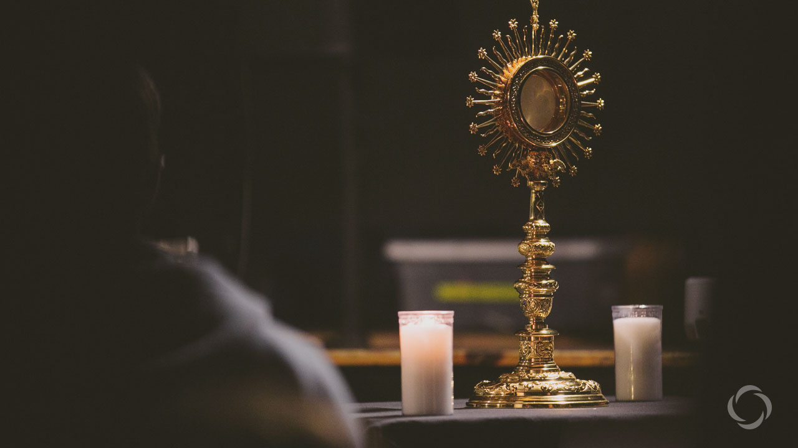
HOW TO PRAY/MY PRAYER/TEEN PRAYER
A Beginner’s Guide to Adoration
by CAITLIN SICA
The first time I went to adoration I was a sophomore in college and it was unintentional.
Really. I was on vacation with a group of friends, but I made sure to check online for the nearest Mass schedule. I pulled into the parking lot at 10:20—10 minutes to spare, life was good. Except…the parking lot was empty. I walked to the front of the church—the doors were locked. I looked at the sign out front and realized I had missed Mass. Slightly panicked, I wasn’t sure what to do. I walked around for a bit and then remembered that this parish had perpetual adoration.
Restless
I walked up the hill to this tiny little chapel, opened the doors, and stepped inside. It was dark, chilly, and extremely quiet. I slid into a pew, knelt, and began to pray. I thought I could hear myself thinking. I looked down at my watch…3 minutes had passed. 3 minutes? I could hardly believe it. I looked next to me at the only other person who was in the chapel—a monk, who was sitting, barefooted, eyes closed, and smiling.
He made it look so easy, so peaceful. I, on the other hand, was in agony. I had promised myself I would stay in adoration for an hour—since that’s about how long Mass was. I closed my eyes, tried to relax. “Pray, Caitlin,” I coached myself, “it’s not that hard.” I opened my eyes. Another 5 minutes had gone by. 52 minutes to go, but who was counting?
Then it dawned on me that my whole attitude was wrong. God wasn’t forcing me to be there, to spend an hour with Him because I had missed Mass. I was choosing to be there. Did I want to be there? Did I want to spend time with Jesus? I did. So I asked God for the grace to let me sit there with Him, in silence, peacefully.
Body, Soul, Blood and Divinity
I gazed upon the monstrance, containing Jesus — body, soul, blood, and divinity — and smiled at the intimacy of it all. I closed my eyes for the third time and prayed. This time, when I opened my eyes an hour had gone by! Halleluiah! I was filled with joy—not because I had fulfilled my made up requirement, but because God had stilled my heart.
I left that chapel filled with a peace, contentment, and joy unlike anything I had felt before.
While it would be six months until I would attend adoration again, God had placed something on my heart—a desire to know Him more fully in the most Blessed Sacrament.
Today, I am a much different person than I was the first time I sat in adoration. I no longer dread the form of prayer, but desire it. I try to go to adoration several times a month. Sometimes, I am able to sit peacefully and sometimes my heart is more restless. But every time, I am grateful for the opportunity to sit and gaze upon the Lord.
5 Ways to be Successful in Adoration
Have you ever gone to adoration? Have you tried, but felt defeated like I first did, and occasionally still do? Here’s a list of 5 ways to be successful in adoration:
1. Be Patient
I was recently talking with a group of friends about their experiences of adoration. A lot of them expressed the same frustration—that sometimes, time seems to stand still, 5 minutes seem eternal. Have you ever been out of shape and tried to go for a one mile run. Suddenly, 5 minutes into the run, you’re huffing and puffing and you realize you’ve only gone one block. Rather than focusing on the success — you just ran for the first time in months!! — we tend to focus on the defeat. Adoration can be a bit of a work out… for your soul. So set yourself up for success. If it’s been awhile, or your first time, 5 minutes of sitting with Jesus is a good goal. Slowly increase your time—you’ll be amazed at how God increases your capacity to be with Him!
2. Bring Scripture
Reading scripture is always a good thing, but is especially helpful and meditative during adoration. There are many prayer books and apps that contain daily scripture readings. I particularly like reading the Psalms and reflecting on a verse that speaks to me on that given day. As I read scripture I ask myself: How is this scripture speaking to my heart? What changes is God asking me to take? How will I go about making those changes? I make this part of my prayer.
3. Pray the Rosary
The rosary is a beautiful prayer, one that many saints have prayed. St. Louis de Montfort said “’When the Holy Rosary is said well, it gives Jesus and Mary more glory and is more meritorious than any other prayer.” What better way to give Jesus and Mary glory than to pray the rosary in front of the Blessed Sacrament? There are many guides and apps you can print/download to help guide you through this form of prayer.
4. Listen to Praise and Worship Music
When I’m the only one in the Church or chapel, I love to start adoration by listening to praise and worship music. “Restless” and “I Shall Not Want” by Audrey Assad, “Lay it Down” and “Lord, I Need You” by Matt Maher, are just a few of my favorite songs to listen to during adoration. The music and the lyrics help me quiet myself and turn my thoughts to God.
5. Be Okay with Silence
It’s so easy to go a whole day without silence. We get in the car and turn on the radio, we have our phones, with days worth of music, in our pockets, and at the end of the day there’s Netflix. Even if we are in a quiet environment, we are usually accustomed to checking our phones—for a text, the latest Facebook drama, the trending hashtag on Twitter, the newest picture on Instagram, the list goes on.
Don’t get me wrong, I fall prey to every one of those habits. Which is why, when I’m sitting in adoration, I can find it difficult to focus. I’ve become so accustomed to the business of the world, that being truly still, truly silent, can seem uncomfortable, foreign. But that discomfort is ok, good even. In Audrey Assad’s “Restless” she sings “And I’m restless, I’m restless, ‘Til I rest in You.” I find this sentiment to be so true when I am in adoration. Sure, the first few minutes I am restless as I begin to wind down. But eventually, I am filled with insurmountable peace. Allow yourself to sit in silence and to just be with Jesus.
In an apparition to St. Margaret Mary Alacoque, Jesus spoke these beautiful words: “I have a burning thirst to be honored by men in the Blessed Sacrament.” Go to adoration, even if it’s just for 5 minutes. Jesus desires to be with you, to have you gaze upon Him, as He so lovingly gazes upon you.
About the Author

Caitlin Sica
I am a New Hampshire girl who’s [imperfectly] striving for sainthood one day at a time, on this messy, grace-filled journey called life. Mondays guarantee a messy bun, I run on coffee, and am always losing my keys. I’m continuing to learn to see God in the most unusual places and in the most unexpected ways. I teach theology at a Catholic high school and received my MA in Theology from the University of Notre Dame.

