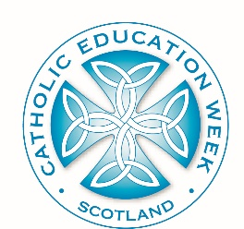
Catholic Education Week 2021/22
“Celebrating and Worshipping”

School Materials – Overview

NOTE: While these ideas and resources have been compiled for Catholic Education Week 2020, many of them could be used throughout the school year.
Different activities can be adapted to meet the context of your school
Characteristic from the Charter for Catholic Schools in Scotland
“a commitment to the spiritual formation of the school community, through the shared experience of prayer and liturgy, and in partnership with local parishes”
Points for reflection | Activity | Outline | Resources
How explicitly do we connect our school calendar to the Church’s Liturgical year? | Planning a period of Eucharistic Adoration, in partnership with the school chaplain or Parish Priest, where possible. | Students will learn about, plan and deliver a period of Adoration for their class group. | School Chaplain or Parish Priest, Oratory, PP, Articles from LifeTeen and Busted Halo
How effectively do we plan assembly prayers & services so that pupils will benefit from them?
How well do we work in partnership with parish and parents to ensure that children are prepared to receive the Sacraments?
How successful is our Chaplaincy Committee/Pastoral Team in supporting our Chaplain to nurture the faith life of our school
“What makes the Catholic school distinctive is its attempt to generate a community climate that is permeated by the Gospel spirit of freedom and love”
Declaration on Christian Education (Gravissimum Educationis), 1965

