**Pope Francis Writes to Young People about Catholic Social Teaching**

**Dear Young People!**

[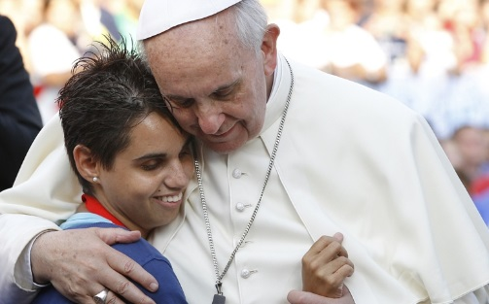](https://www.google.co.uk/url?sa=i&rct=j&q=&esrc=s&source=images&cd=&cad=rja&uact=8&ved=0ahUKEwjc3Ir62PDXAhUC12MKHTE6Al0QjRwIBw&url=https://www.ncronline.org/news/vatican/real-test-francis-reform-touching-spiritually-poor&psig=AOvVaw2uvJUhXkxTz6LhOR2ZLvSi&ust=1512488466450178)Jesus says: “As you did it to one of the least of these my brethren, you did to me.” Many saints were shaken to the core by this passage from the Bible. On account of it, Saint Francis of Assisi changed his whole life. Mother Teresa converted because of this saying. And Charles de Foucauld acknowledges: “In all of the Gospel, there is no saying that had greater influence on me and changed my life more deeply than this: ‘Whatsoever you did for one of the least of my brethren, you did for me.’ When I reflect that these words come from the mouth of Jesus, the Eternal Word of God, and that it is the same mouth that says, ‘This is my Body, … this is my Blood …’, then I see that I am called to seek and to love Jesus above all in these little ones, in the least.”

Dear young friends! Only conversion of heart can make our world, which is full of terror and violence, more humane. And that means patience, justice, prudence, dialogue, integrity, solidarity with victims, the needy, and the poorest, limitless dedication, love even unto death for the sake of the other. When you have understood that quite deeply, then you can change the world as committed Christians. The world cannot continue down the path that it is taking now. If a Christian in these days looks away from the need of the poorest of the poor, then in reality he is not a Christian!

What we call Catholic social teaching today came about in the nineteenth century. With industrialization, a brutal form of capitalism arose: a sort of economy that destroyed human beings. Unscrupulous industrialists reduced the impoverished rural population to the point where they toiled in mines or in rusty factories for starvation wages. Children no longer saw the light of day. They were sent underground like slaves to pull coal carts. With great commitment, Christians offered aid to those in need, but they noticed that that was not enough. So they developed ideas for counteracting the injustice socially and politically as well. Actually, the fundamental proclamation of Catholic social doctrine was and is the 1891 encyclical letter by Pope Leo XIII, Rerum novarum, “On Capital and Labor.” The Pope wrote clearly and unmistakably: “To defraud any one of wages that are his due is a great crime which cries to the avenging anger of Heaven.” With the full weight of her authority, the Church fought for the rights of the workers.

Because the needs of the time demanded it, Catholic social teaching was increasingly enriched and renewed over the years. Many people debated about community, justice, peace, and the common good. But actually this social doctrine does not come from any particular pope or from any particular scholar. It comes from the heart of the Gospel. It comes from Jesus himself. Jesus is the social teaching of God.

“This economy kills”, I wrote in my apostolic exhortation Evangelii Gaudium, for today that economy of exclusion and disparity of incomes still exists. There are countries in which 40 or 50 percent of the young people are unemployed. In many societies, older people are marginalized because they seemingly have no “value” and are no longer “productive”. Great stretches of land are depopulated because the poor of the earth flee to the slums of the major cities in the hope of finding something left there on which to survive. The production methods of a globalized economy have destroyed the modest economic and agricultural structures of their native regions. By now, approximately 1 percent of the world’s population owns 40 percent of the entire wealth of the world, and 10 percent of the world’s population owns 85 percent of the wealth. On the other hand, just about 1 percent of this world “belongs” to half of the world’s population. About 1.4 billion human beings live on less than one euro [approximately $1.10] per day.

When I invite you all now really to get to know the social doctrine of the Church, I am dreaming not just about groups that sit under trees and discuss it. That is good! Do that! My dream is of something greater: I wish I had a million young Christians or, even better, a whole generation who are for their contemporaries “walking, talking social doctrine”. Nothing else will change the world but people who with Jesus devote themselves to it, who with him go to the margins and right into the middle of the dirt. Go into politics, too, and fight for justice and human dignity, especially for the poorest of the poor. All of you are the Church. Make sure, then, that this Church is transformed, that she is alive, because she allows herself to be challenged by the cries of the dispossessed, by the pleading of the destitute, and by those for whom nobody cares.

Become active yourselves, also. When many do that together, then there will be improvements in this world and people will sense that the Spirit of God is working through you. And maybe then you will be like torches that make the path to God brighter for these people. I pray every day for you. Pray for me, too!

Yours truly,

