**Four Key Catholic Social Teaching Principles**

**Human Dignity**

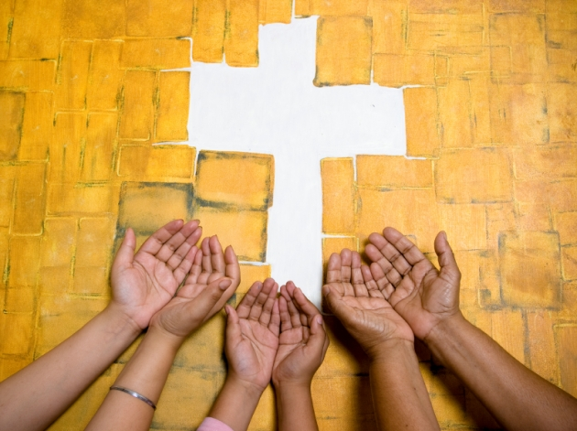The most fundamental Catholic Social Teaching principle is the dignity of the human person. Because each person is created in the image and likeness of God, each one has a transcendent dignity that can never be taken away, even if it is not always respected. People are always more important than things. People must never be treated as a means or an instrument to be used for the benefit of another.

Our human dignity gives rise to human rights. Each person is equal in dignity and rights. In the same way, every human community, every race and culture is equal in dignity and rights. The human family is one because we are all children of the one God.

**When we are thinking about human dignity, a key question to ask is:  
“What is happening to people?”**

**The Common Good**

“To love someone is to desire that person’s good and to take effective steps to secure it. Besides the good of the individual, there is a good that is liked to living in society: the common good. It is the good of ‘all of us’, made up of individuals, families and intermediate groups who together constitute society … To take a stand for the common good is on the one hand to be solicitous for, and on the other hand to avail oneself of, that complex of institutions that give structure to the life of society, juridically, civilly, politically and culturally, making it the polis, or ‘city’.”  
Benedict XVI, Caritas in Veritate, n 7

The principle of the common good reminds us that we are all really responsible for each other. We must work for social conditions which ensure that every person and every group in society is able to meet their needs and realize their potential. Every group in society must take into account the rights and aspirations of other groups, and the well-being of the whole human family.

**When we are thinking about the common good, key questions to ask ourselves are:  
“Is every group able to share in the benefits of society?”  
“Are some groups excluded?”**

**Solidarity**

“Solidarity helps us to see the ‘other’ – whether a person, people, or nation – not just as some kind of instrument, with a work capacity and physical strength to be exploited at low cost and then discarded when no longer useful, but as our neighbour, a helper (cf Gn 2:18-20), to be a sharer, on a par with ourselves, in the banquet of life to which all are equally invited by God.”  
John Paul II, Sollicitudo Rei Socialis, n 39

We are made in the likeness of God who is a community of three persons in perfect relationship. God is community and makes community. Human beings cannot survive without others and can only grow and achieve our potential in relationship with others – we are social by nature. It follows that our salvation is bound up with that of each other. Solidarity is not just a vague feeling of empathy or compassion. It is a firm and persevering determination to commit oneself to the common good.

**When we are thinking about solidarity key questions are:  
“Who do we really care about?”  
“Would we like this to happen to us?”**

**Subsidiarity**

“Subsidiarity is first and foremost a form of assistance to the human person via the autonomy of intermediate bodies. Such assistance is offered when individuals or groups are unable to accomplish something on their own, and it is always to achieve their emancipation, because it fosters freedom and participation through assumption of responsibility. Subsidiarity respects personal dignity by recognising in the person a subject who is always capable of giving something to others… It is able to take account both of the manifold articulation of plans – and therefore the plurality of subjects – as well as the coordination of those plans.”  
Benedict XVI, Caritas in Veritate, n 57

The principle of subsidiarity is about how participation and decision-making should be organised. Responsibility should be kept as close as possible to the grassroots. The people or groups most directly affected by a decision or policy should have a key decision-making role in it. More encompassing groups should only get involved to support smaller, more local groups when they need help. Sometimes this is necessary in order to coordinate their activities with the activities of other groups in order to promote the common good. It is from this aspect of help offered by larger to smaller groups that the term subsidiarity (from the Latin *subsidium* for help or assistance) comes.

**Key questions in relation to subsidiarity are:  
“Who is making the decisions?”  
“Can everyone participate?”**