What are protected characteristics?

There are nine characteristics protected under the [Equality Act 2010](https://www.equalityhumanrights.com/en/equality-act/equality-act-2010). They are:

* [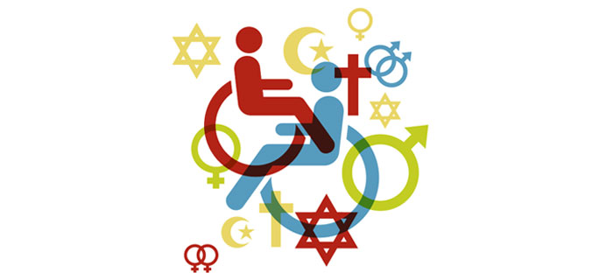](http://www.google.co.uk/url?sa=i&rct=j&q=&esrc=s&source=images&cd=&cad=rja&uact=8&ved=2ahUKEwjR7qTljNjZAhULDMAKHYkgDbMQjRx6BAgAEAY&url=http://www.allenovery.com/publications/en-gb/Pages/Protected-characteristics-and-the-perception-reality-gap.aspx&psig=AOvVaw16nm18BNLhwXJcLwMGsnKe&ust=1520439524047996)[age](https://www.equalityhumanrights.com/en/equality-act/protected-characteristics#age)
* [disability](https://www.equalityhumanrights.com/en/equality-act/protected-characteristics#disability)
* [gender reassignment](https://www.equalityhumanrights.com/en/equality-act/protected-characteristics#reassignment)
* [marriage and civil partnership](https://www.equalityhumanrights.com/en/equality-act/protected-characteristics#marriage)
* [pregnancy and maternity](https://www.equalityhumanrights.com/en/equality-act/protected-characteristics#pregmat)
* [race](https://www.equalityhumanrights.com/en/equality-act/protected-characteristics#race)
* [religion or belief](https://www.equalityhumanrights.com/en/equality-act/protected-characteristics#rob)
* [sex](https://www.equalityhumanrights.com/en/equality-act/protected-characteristics#sex)
* [sexual orientation](https://www.equalityhumanrights.com/en/equality-act/protected-characteristics#lgb)

Age

A person belonging to a particular age (for example 32 year olds) or range of ages (for example 18 to 30 year olds).

Disability

A person has a disability if she or he has a physical or mental impairment which has a substantial and long-term adverse effect on that person's ability to carry out normal day-to-day activities.

Gender reassignment

The process of transitioning from one gender to another.

Marriage and civil partnership

Marriage is a union between a man and a woman or between a same-sex couple.

Same-sex couples can also have their relationships legally recognised as 'civil partnerships'. Civil partners must not be treated less favourably than married couples (except where permitted by the Equality Act).

Pregnancy and maternity

Pregnancy is the condition of being pregnant or expecting a baby. Maternity refers to the period after the birth, and is linked to maternity leave in the employment context. In the non-work context, protection against maternity discrimination is for 26 weeks after giving birth, and this includes treating a woman unfavourably because she is breastfeeding.

Race

Refers to the protected characteristic of race. It refers to a group of people defined by their race, colour, and nationality (including citizenship) ethnic or national origins.

Religion and belief

Religion has the meaning usually given to it but belief includes religious and philosophical beliefs including lack of belief (such as Atheism). Generally, a belief should affect your life choices or the way you live for it to be included in the definition.

Sex

A man or a woman.

Sexual orientation

Whether a person's sexual attraction is towards their own sex, the opposite sex or to both sexes.