Catholic Education Week 2024

“Pilgrims of Hope”
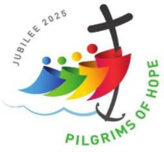

“In the one People of God, therefore, let us journey together, in order to experience a Church that receives and lives this gift of unity, and is open to the voice of the Spirit,”
Pope Francis October 2021
Leader:
Each year, during Catholic Education Week, we are encouraged to take time to reflect on the ways in which our homes, schools and parishes work together to accompany our young people on their faith journey.
As we pray together today, filled with the Spirit, let us use this opportunity to quietly reflect on the ways in which we can strive to ensure that our school community, is one in which all are encouraged to use and develop their God given gifts, to bring Christ’s love to all. Is our school community one in which we encounter Christ in our daily lives and sharing journey of faith with each other?
Let us pray together:
Opening Prayer - Adsumus Sancte Spiritus (prayer used for the Synod)

We stand before You, Holy Spirit,
as we gather together in Your name.

With You alone to guide us,
make Yourself at home in our hearts;
Teach us the way we must go
and how we are to pursue it.

We are weak and sinful;
do not let us promote disorder.
Do not let ignorance lead us down the wrong path
nor partiality influence our actions.

Let us find in You our unity
so that we may journey together to eternal life
and not stray from the way of truth
and what is right.

All this we ask of You,
who are at work in every place and time,
in the communion of the Father and the Son,
forever and ever.

Amen.

Leader:
We pray that we will be open to welcoming the Holy Spirit to be at work in us, so that we may be a community and a people of grace.
Liturgy of the Word
A reading from the first letter of St. Paul to the Corinthians

There is a variety of gifts, but always the same spirit;
there are all sorts of service to be done,
but always to the same Lord;
working in all sorts of different ways to different people,
it is the same God who is working in all of them.

The particular way in which the Spirit is given to each person
is for a good purpose.
One may have the gift of preaching with wisdom
given him by the Spirit;
another may have the gift of preaching instruction
given him by the same Spirit;
another the gift of healing,
through this one Spirit;
one, the power of miracles;
another prophecy;
another the gift of recognising spirits;
another the gift of tongues
and another the ability to interpret them.

All these are the work one and the same Spirit,
Who distributes different gifts to different people just as he chooses.

Just as a human body, though it is made up of many parts,
Is a single unit because all these parts, though many, make one body,
so it is with Christ.

In the one Spirit we were all baptised,
Jews as well as Greeks,
slaves as well as citizens,
and one Spirit was given to us all to drink.

The word of the Lord.
Let us pray:
O God, help us to recognise in ourselves and in others, the gifts that have been given by the Spirit. Help us to understand that these gifts are given freely and given to help us to serve the common good. May we use our gifts to do good work to the glory of God and for the benefit of the entire Church.
A reading from the Holy Gospel according to Matthew:
He said,
‘All authority in heaven and on earth has been given to me.
Go, therefore, make disciples of all nations;
Baptise them in the name of the Father and of the Son
And of the Holy Spirit,
And teach them to observe all the command I gave you.
And know that I am with you always;
Yes, to the end of time.

Let us pray
O God, we pray that with the Spirit’s strength and guidance we will willingly accept the invitation to take Christ’s peace, joy and love to all.

Leader:
Pope Francis is asking us to walk together as members of the Church. He reminds us that the synod on synodality, is not about “gathering opinions,” but “listening to the Holy Spirit.”
Let us pause to consider the ways in which our school community can reflect this message:
Are we united with one another in the communion of one people of God?
Do we seek opportunities to allow all members of our school community to participate in the life of the Church?
Are we encouraged to think about how each one of us has a role in the Church’s mission to share the Good News of Christ?
Do we witness this call in what we say and in the way we live our lives?
Do we share our thoughts and reflections with others and actively listen to the thoughts of others?

Prayers of Intercession
Lord bless our bishops, priests, deacons and religious leaders: help them use to their gifts in our schools and parishes to foster a spirit of communion, participation and mission.
Lord, in your mercy.
Hear our prayer.
Lord, bless our world leaders: grant them the gifts of courage, compassion and wisdom to enable them to govern wisely and justly. May they be inspired by the example of Christ.
Lord, in your mercy.
Hear our prayer.

Lord, bless all staff working in our school communities. May they be filled with the Spirit’s strength, growing in love, patience, forgiveness and understanding as they accompany our young people on their faith journey as pilgrims of hope.

Lord, in your mercy.
Hear our prayer.

Lord, bless those who suffer in any way. May your healing hand guide those who care for them and help them to use their gifts to bring them comfort and support.
Lord in your mercy.
Hear our prayer.

Lord, we pray for all who have died. May they rest in the peace of Christ and rise in glory on the last day.
Lord, in your mercy
Hear our prayer

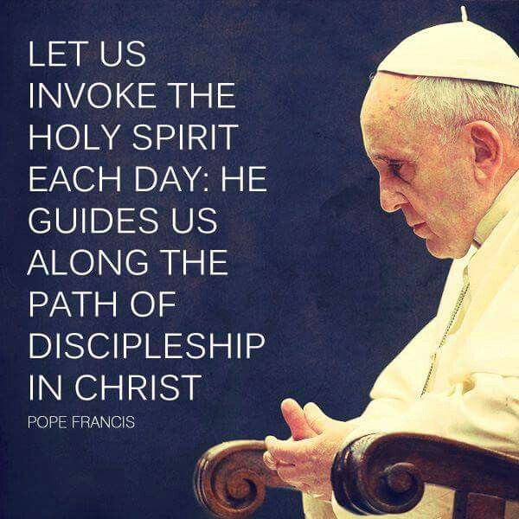

Dear brothers and sisters, let us have a good journey together! May we be pilgrims in love with the Gospel and open to the surprises of the Holy Spirit. Let us not miss out on the grace-filled opportunities born of encounter, listening and discernment. In the joyful conviction that, even as we seek the Lord, he always comes with his love to meet us first.
Pope Francis October 10 2021

