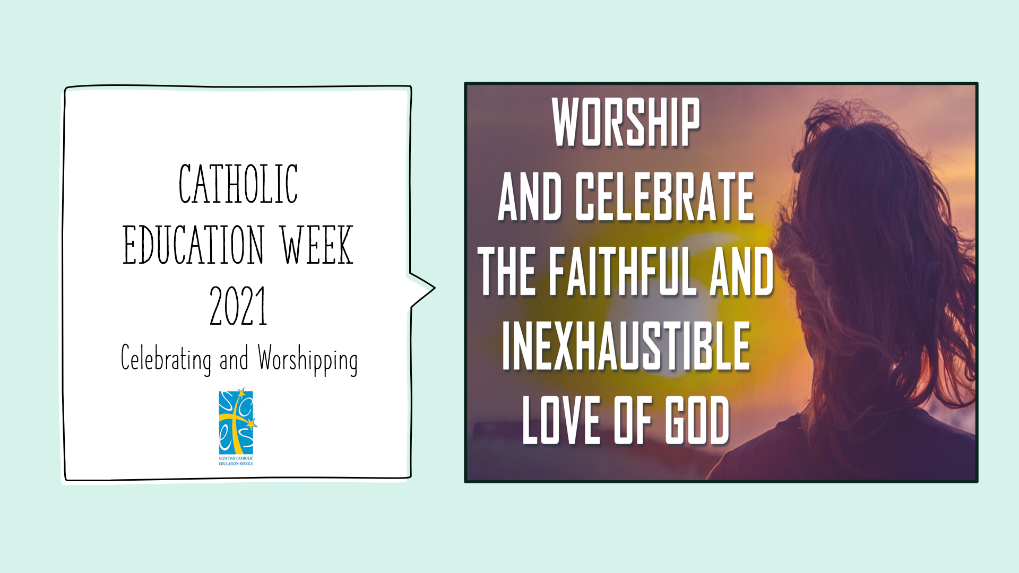

CATHOLIC EDUCATION WEEK 2021 – CELEBRATING AND WORSHIPPING
SECONDARY ASSEMBLY
NOTES

The assembly comes in the form of a PowerPoint presentation of 16 slides, broken down into 5 sections:
- The statement on Celebrating and Worshipping from “The Catholic School: Developing in Faith”. (Slides 2 – 6)
- An exploration of the word “celebrate” in this context (Slide 7)
- An exploration of the word “worship” in this context ( based upon Pope Francis’ homily for 6th January 2020) (Slides 8 – 10)
- The centrality of the Eucharist in Catholic celebration & worship (slides 11 & 12)
- Reflection and Prayer (Slides 13 – 16)

Each slide has speakers’ notes on the notes pages of the presentation itself, which can be used as a full script, but schools can adapt and personalise these to suit their own contexts.

